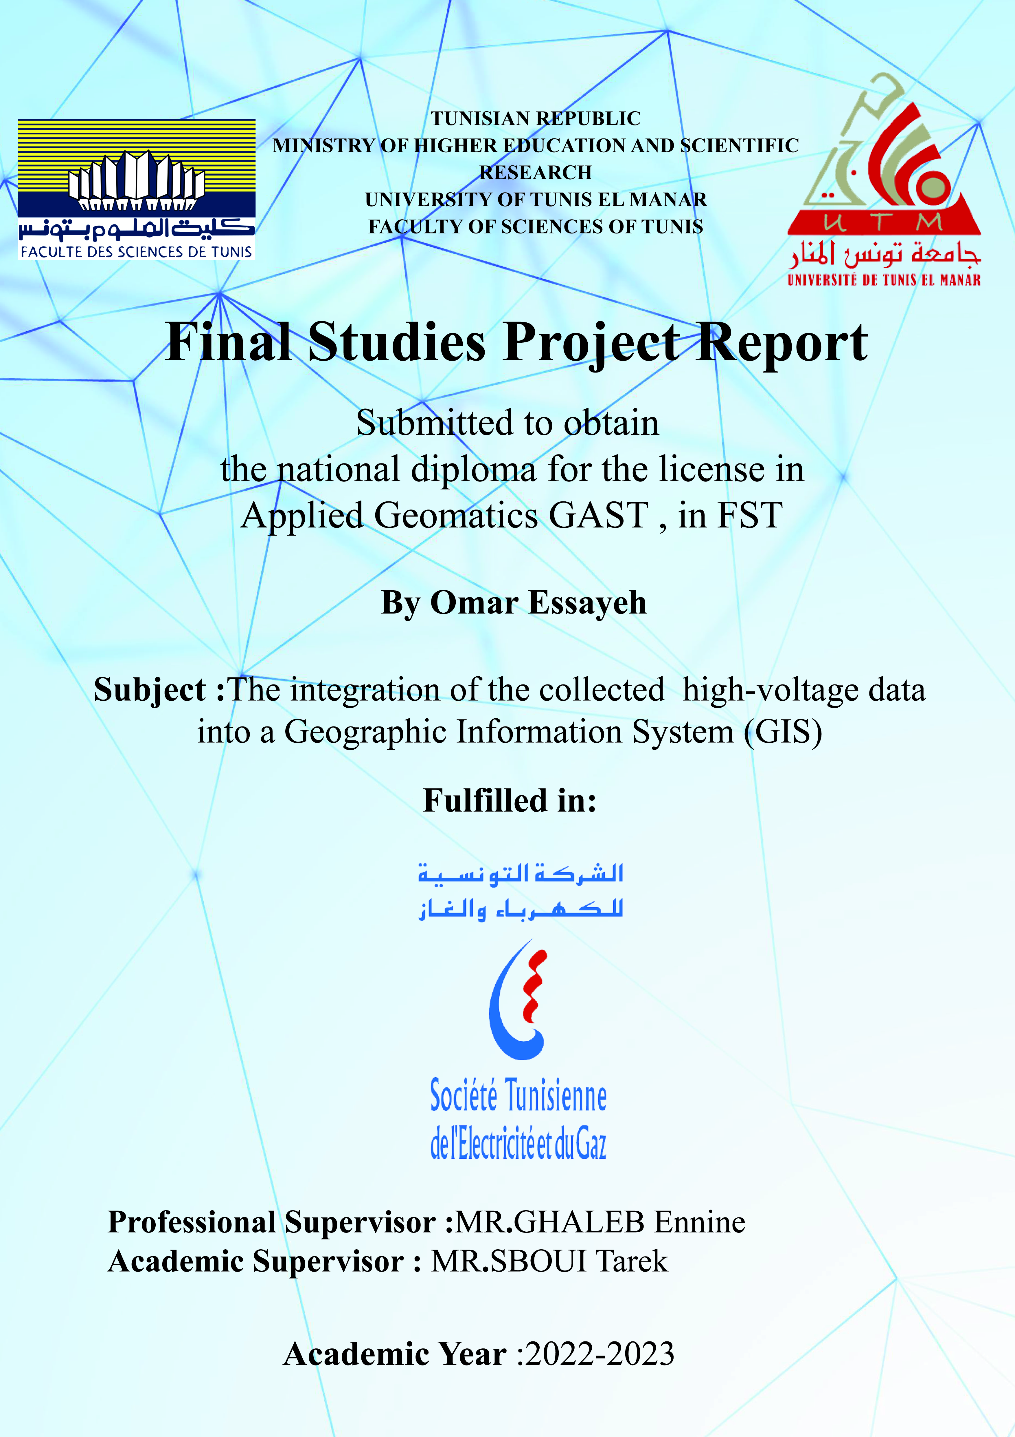

**My word of gratitude:**

It seems appropriate to begin this internship report by thanking those who taught me a lot during course of this internship and who were kind enough to make it a very profitable moment.

First of all, my thanks go particularly to Mr.Ghaleb Ennine my supervisor at the STEG for the honor which he attributed for having accepted to direct this work. His availability during all stages of this work, for his patience when welcoming him for individual meetings and the time spent together to guide me, his relevant comments and suggestions have constantly improved the quality of this document.

I would particularly like to thank Mr. Sboui Tarek my professor at the faculty of science TUNIS MANAR for the help and guidance he provided during the stages of the internship.

Thanks also to my parents who spent their time and effort without a second thought to push me for successes and the pursuit of good career and happy life.

Finally, I extend my respectful thanks to the members of the jury for having agreed to judge my work.

Table of contents

1. Introduction of the Project framework: 4

2. Presentation of the STEG: 5

2.1 What is the STEG: 5

2.2 STEG in numbers: 5

3. Electricity Transmission network: 8

3.1 Description of the transport network: 8

3.2 Description of the voltage levels: 9

3.3 Brief description of the electricity distribution network: 10

4. Description of the Geomatics: 10

4.1 What is Geomatics : 10

4.2 Geographic data: 12

4.3 Geographic information system: 13

4.4 Contribution of GIS to STEG: 14

5. Integration into the Geo-spatial Database (POSTGRES-POSTGIS): 15

5.1 Description of the ‘HTB’ dictionary of data: 15

5.2 Description of the codification of the tables: 15

5.3 Logical Data Model (LDM) and Conceptual Data Model (CDM) of the HTB network data (use of **ENTERPRISE ARCHITECT**): 15

5.3.1 Conceptual Data Model (MCD): 15

5.3.2 Logical Data Model (LDM): 16

5.3.3 Postgres/PostGIS: 16

5.3.4 ENTERPRISE ARCHITECT: 17

5.4 SQL code generation: 29

5.5 Creation of the drop-list for the type of the features: 31

5.5.1 Visual studio code: 31

5.5.2 SQL: 31

5.5.3 The script: 32

5.6 Integration into the geo-spatial database (PostgresSQL, PostGIS): 34

5.6.1 Setting up the environment: 34

5.6.2 Integration with terminal command (cmd): 36

6. Workflow between QGIS and postgresql/postgis: 39

6.1 What is QGIS : 39

6.2 Connection between POSTGRESQL/QGIS: 40

6.3 Development of symbology and labels for each table: 42

6.4 Digitization of the HTB network: 47

6.5 SQL queries: 54

6.5.1 Altering constraints, updating tables: 54

6.5.2 Verification of digitized data in PostgreSQL/PostGIS: 56

7. Conclusion: 58

8. Tables: 59

9. Figure : 59

10. Bibliography 62

# Introduction of the Project framework:

STEG has the monopoly of production, transmission and distribution of electricity and Gas in Tunisia and has to operate and maintain a complex electricity and gas grids.

However, network mapping at STEG is generally in paper, digital mapping is limited to non-georeferenced files on AutoCAD. Also, the retirements of several cartographers are not replaced which lead to the loss of information on the grids history characteristics.

STEG has to introduce a well-thought GIS program in order to better manage these complex grids, for the different phases of planning, construction, operating and monitoring.

The framework of my PFE consists in mastering the electricity transmission field, to demonstrate the solid workflow between QGIS software and the database

“PostgreSQL/PostGIS” and finally setting up a methodology to integrate the High Voltage network (HTB) into the GIS, with using practical examples of High Voltage lines and their components.

# Presentation of the STEG:

## What is the STEG:

STEG stands for ‘Société Tunisienne de l'Électricité et du Gaz’, which translates to the Tunisian Company of Electricity and Gas. STEG is the national utility company responsible for the production, distribution, and supply of electricity and natural gas in Tunisia. It was established in 1962 and operates under the supervision of the Ministry of Industry and SMEs in Tunisia. STEG plays a crucial role in ensuring the availability and reliability of electricity and gas services for residential, commercial, and industrial consumers throughout the country. (1)

## STEG in numbers:

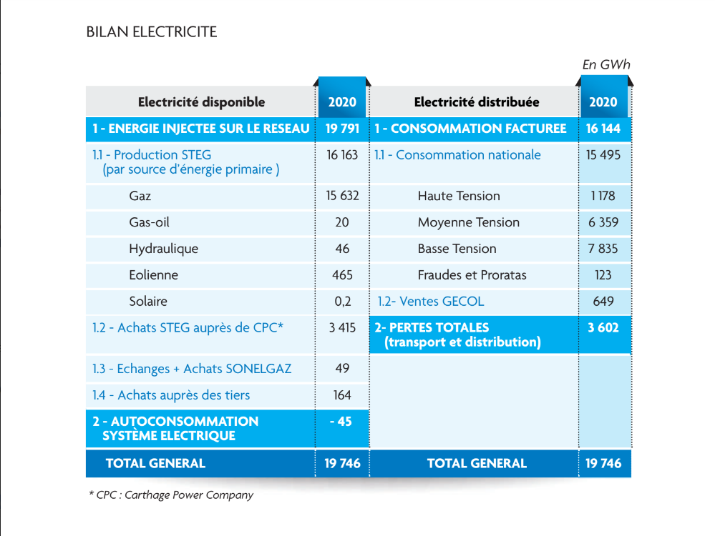

Figure 1: Electricity balance

|  |  |  |  |  |  |  |  |  |  |  |  |  |  |  |  |  |  |  |  |  |  |  |  |  |  |  |  |  |  |  |  |  |  |  |  |  |  |  |  |  |  |  |  |  |  |  |  |  |  |  |  |  |  |  |  |  |  |  |  |  |  |  |  |  |  |  |  |  |  |  |  |  |  |  |  |  |  |  |  |  |  |  |  |  |  |  |  |  |  |  |  |  |  |  |  |  |  |  |  |  |  |  |  |  |  |  |  |  |  |  |  |  |  |  |  |  |  |  |  |  |  |  |  |  |  |  |  |  |  |  |  |  |  |  |  |  |  |  |  |  |  |  |  |  |  |  |  |  |  |  |  |  |  |
| --- | --- | --- | --- | --- | --- | --- | --- | --- | --- | --- | --- | --- | --- | --- | --- | --- | --- | --- | --- | --- | --- | --- | --- | --- | --- | --- | --- | --- | --- | --- | --- | --- | --- | --- | --- | --- | --- | --- | --- | --- | --- | --- | --- | --- | --- | --- | --- | --- | --- | --- | --- | --- | --- | --- | --- | --- | --- | --- | --- | --- | --- | --- | --- | --- | --- | --- | --- | --- | --- | --- | --- | --- | --- | --- | --- | --- | --- | --- | --- | --- | --- | --- | --- | --- | --- | --- | --- | --- | --- | --- | --- | --- | --- | --- | --- | --- | --- | --- | --- | --- | --- | --- | --- | --- | --- | --- | --- | --- | --- | --- | --- | --- | --- | --- | --- | --- | --- | --- | --- | --- | --- | --- | --- | --- | --- | --- | --- | --- | --- | --- | --- | --- | --- | --- | --- | --- | --- | --- | --- | --- | --- | --- | --- | --- | --- | --- | --- | --- | --- | --- | --- | --- | --- |
| Table 1: HV-MV Electricity Sales by Economic Sector   |  |  |  |  |  |  |  |  |  | | --- | --- | --- | --- | --- | --- | --- | --- | --- | | Economic sector | * 2022 | 2021 | 2020 | 2019 | 2018 | 2017 | 2016 | 2015 | | Ind. Extractives | 313 | 310 | 286 | 317 | 308 | 322 | 318 | 305 | | Ind. Alimentation | 608 | 635 | 660 | 703 | 687 | 688 | 673 | 703 | | Industry Textiles | 484 | 458 | 422 | 476 | 457 | 440 | 458 | 480 | | Ind. Paper and Edition | 98 | 95 | 80 | 105 | 110 | 119 | 141 | 146 | | Chemical Industry | 611 | 588 | 535 | 495 | 493 | 458 | 440 | 468 | | Ind. Construction material | 1 373 | 1 457 | 1 253 | 1 451 | 1 472 | 1499 | 1568 | 1 659 | | Ind. Metallurgies | 300 | 285 | 262 | 256 | 284 | 253 | 283 | 268 | | Miscellaneous Industry | 1 265 | 1 165 | 1 054 | 1 150 | 1 159 | 1 095 | 1 034 | 1 027 | | Total 1 | 5 052 | 4 993 | 4 552 | 4 953 | 4 970 | 4 874 | 4 915 | 5 056 | |  | | | | | | | | | | Agriculture | 698 | 700 | 659 | 634 | 606 | 589 | 602 | 565 | | Pumping & Sanitary Services | 888 | 872 | 850 | 752 | 766 | 792 | 684 | 620 | | Transport | 271 | 258 | 252 | 284 | 305 | 298 | 285 | 298 | | Tourism | 505 | 337 | 292 | 581 | 540 | 492 | 430 | 463 | | Services | 1 022 | 978 | 932 | 1014 | 971 | 961 | 944 | 940 | | Total 2 | 3 384 | 3 145 | 2 985 | 3 265 | 3 188 | 3 132 | 2 945 | 2 886 | |

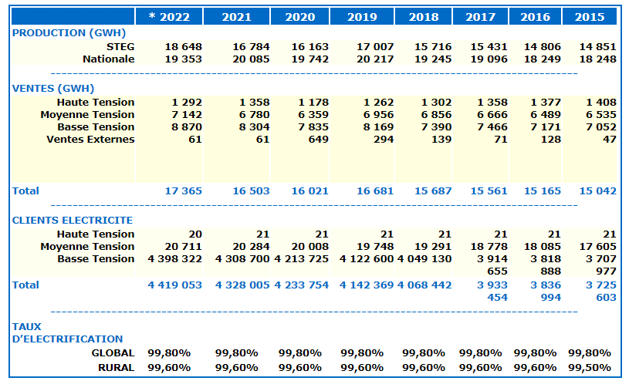

Figure 2: Electricity activities

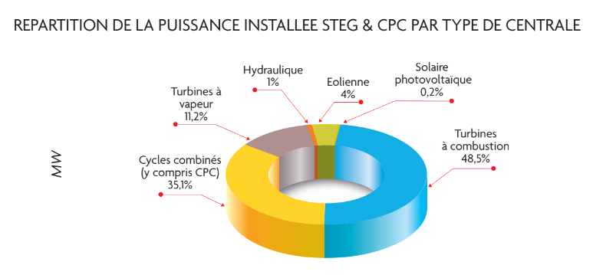

Figure 3: Breakdown of installed power STEG and CPC by type of power plant

# Electricity Transmission network:

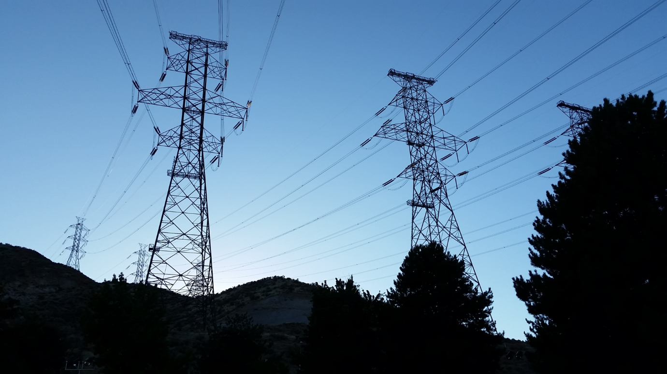Electric power transmission is the bulk movement of [electrical energy](https://en.wikipedia.org/wiki/Electrical_energy) from a [generating](https://en.wikipedia.org/wiki/Power_generation) site, such as a [power plant](https://en.wikipedia.org/wiki/Power_plant), to an [electrical substation](https://en.wikipedia.org/wiki/Electrical_substation). The interconnected lines that facilitate this movement form a transmission network.

Figure 4:500 kV three-phase electric power Transmission Lines

This is distinct from the local wiring between high-voltage substations and customers, which is typically referred to as [electric power distribution](https://en.wikipedia.org/wiki/Electric_power_distribution). The combined transmission and distribution network is part of [electricity delivery](https://en.wikipedia.org/wiki/Electricity_delivery), known as the [electrical grid](https://en.wikipedia.org/wiki/Electrical_grid).  
(2)

## Description of the transport network:

Electricity is transmitted at [high voltages](https://en.wikipedia.org/wiki/High_voltage) to reduce the energy loss that occurs over long distances. Power is usually transmitted through [overhead power lines](https://en.wikipedia.org/wiki/Overhead_power_line). [Underground power transmission](https://en.wikipedia.org/wiki/Underground_power_transmission) has a significantly higher installation cost and greater operational limitations, but lowers maintenance costs.

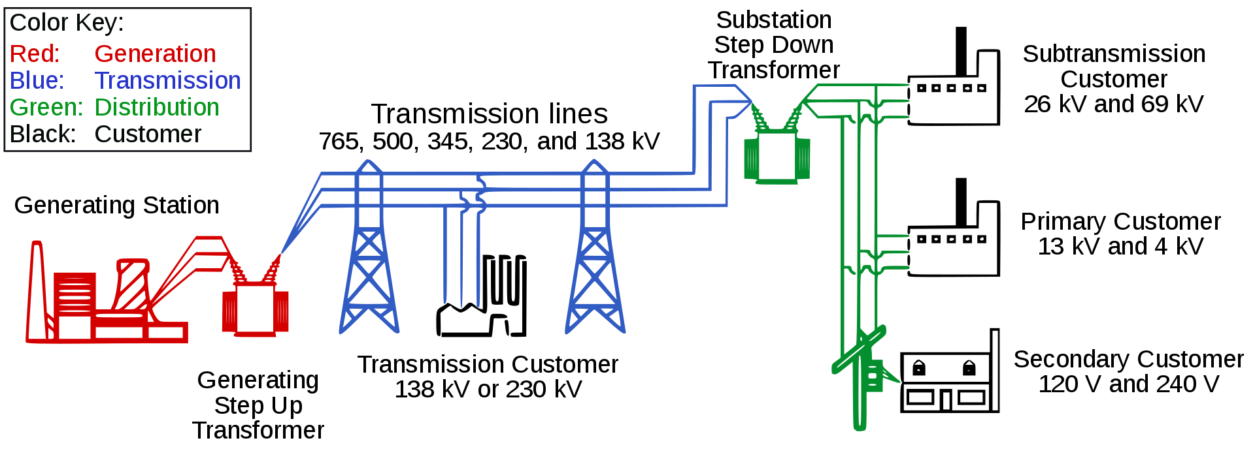Underground transmission is more common in urban areas or environmentally sensitive locations.

Figure 5: A diagram of an electric power system.

Electrical energy must typically be generated at the same rate at which it is consumed. A sophisticated control system is required to ensure that [power generation](https://en.wikipedia.org/wiki/Power_generation) closely matches demand. If demand exceeds supply, the imbalance can cause generation plant(s) and transmission equipment to automatically disconnect or shut down to prevent damage. In the worst case, this may lead to a cascading series of shutdowns and a major regional [blackout](https://en.wikipedia.org/wiki/Power_outage). (3)

## Description of the voltage levels:

Table : Voltage Description

|  |  |  |
| --- | --- | --- |
|  | Voltage level | Description |
| Low voltage | 230 volts / single-phase  400volts / three-phase | Used for residential, commercial, and small-scale industrial consumers, powering lighting, appliances, and other electrical devices. |
| Medium voltage | 30 Kilo-volts | Used to supply power to larger consumers such as factories, commercial buildings, and residential complexes. |
| High voltage | <90 kilovolts | used in the transmission of electricity over long distances from power plants to distribution substations |

## Brief description of the electricity distribution network:

The electricity distribution network is an essential component of the overall electric power system. It is responsible for delivering electricity from high-voltage transmission lines to end-users, such as residential, commercial, and industrial consumers. The distribution network operates at lower voltage levels compared to the transmission network, making it suitable for local consumption. (1)

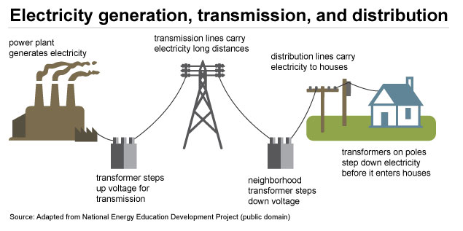

Figure 6:Electricity generation , transmission and distribution

# Description of the Geomatics:

## What is Geomatics :

Geomatics is the contraction of the terms "geography" and "computing". It is a set of technologies to model, represent and analyse the territory

to make virtual representations of them: geolocation, spatial imagery, databases data, GIS (Geographic Information System), web technologies, etc.

Geomatics is widely open to all economic sectors:

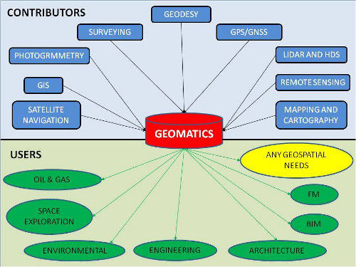Sustainable land development and planning, agriculture,

Figure 7: Contributors and Users of the GEOMATICS

resource management, transport, town planning, space industry, network managers ,

roads, telecommunications, energy, defence and geomarketing.

Geomatics brings together in a coherent way all the knowledge and technologies necessary for the production and processing of digital data describing the territory, its resources or any other object or phenomenon having a geographical position.  
(4)

## Geographic data:

|  |  |
| --- | --- |
| Figure 8: Raster representation | Figure 9: Vector representation |

|  |  |
| --- | --- |
| **Raster:**  Raster data look like grids because they store data in rows and columns. They can be discrete or continuous. For example, we often represent land cover, temperature data, and imagery as raster data. | **Vector:**  Vectors are points, lines, and polygons with vertices. For example, fire hydrants, contours, and administrative boundaries are often vectors. |

(4)

## Geographic information system:

Geographic Information Systems (GIS) store, analyse, and visualize data for geographic positions on Earth’s surface.

GIS stands for Geographic Information Systems and is a computer-based tool that examines spatial relationships, patterns, and trends in geography.

|  |  |
| --- | --- |
| GIS mapping produces visualizations of geospatial information.  The 4 main ideas of Geographic Information Systems (GIS) are:   * Create geographic data. * Manage it in a database. * Analyse and find patterns. * Display it on a map.   Because viewing and analysing data on maps impacts our understanding of data, we can make better decisions using GIS.  (4) | GIS Layers  Figure 10: GIS data layering |

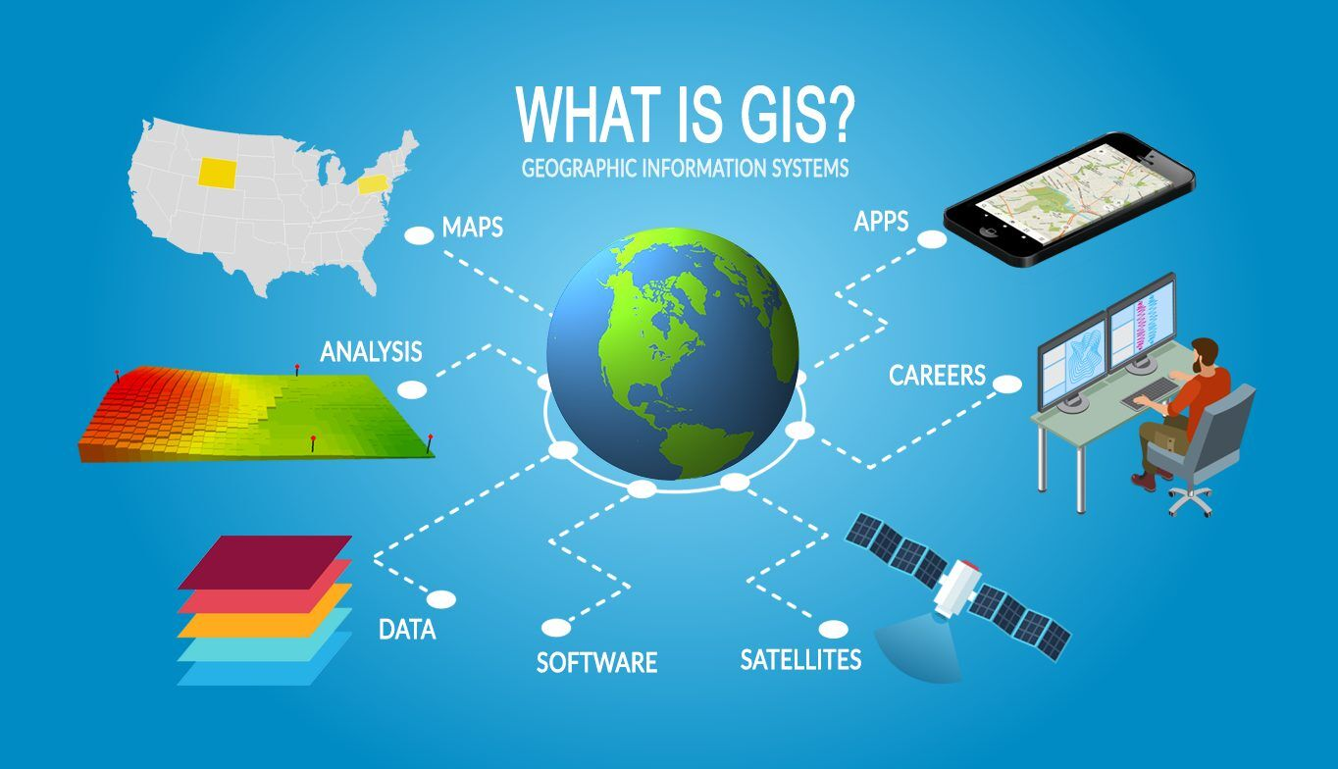

Figure 11: The different components of a geographic information system.

It helps us understand what is where. The analysis becomes simple. Answers become clear.

Because you don’t fully understand your data until you see how it relates to other things in a geographic context.

(4)

## Contribution of GIS to STEG:

* Single repository for mapping electricity and gas networks.
* Preserve the heritage and traceability of networks.
* Optimize studies requiring the geo-spatial component.
* Better organize the databases and the data relations.
* Improve security against external attacks on the networks (better coordination with dealers and third parties, etc.).
* Possibility of developing business applications integrated into the GIS solution (for example: automatic calculation of the estimate, etc.).

# Integration into the Geo-spatial Database (POSTGRES-POSTGIS):

## Description of the ‘HTB’ dictionary of data:

The HTB dictionary of data contains the tables that forms the database,

* 4 tables of polygon geometry representing the production and distribution sites of electricity
* 2 tables of string line geometry representing the lines of transmission
* 2 tables of point geometry representing the electricity towers and electricity junctions

## Description of the codification of the tables:

Each tables has a GIS id of the type ‘serial’ and a codification based on the codification document provided by the STEG , these codification was used to identify production sites , source sites of high voltage electricity and cables (areal and underground) it belongs to

## Logical Data Model (LDM) and Conceptual Data Model (CDM) of the HTB network data (use of **ENTERPRISE ARCHITECT**):

### Conceptual Data Model (MCD):

Conceptual data models are used in the earlier stages of data modelling to organize and define concepts and rules based on use-case requirements. They are the least detailed of the three types of data models.

Conceptual data models provide organizations with a starting point that should be evolved into more context rich diagrams as they move through the stages of data models. Through use-case analysis, use-case design and database design, the complexity and level of detail will eventually peak with physical data models. (5)

### Logical Data Model (LDM):

A logical model contains representations of entities and attributes, relationships, unique identifiers, subtypes and super types, and constraints between relationships. A logical model can also contain domain model objects, or reference one or more domain or glossary models. After logical objects and relationships are defined in a logical data model, you can use the workbench to transform the logical model into a database-specific physical representation in the form of a physical data model. (6)

### Postgres/PostGIS:

* + - 1. Postgres:

PostgreSQL  also known as Postgres, is a [free and open-source](https://en.wikipedia.org/wiki/Free_and_open-source_software) [relational database management system](https://en.wikipedia.org/wiki/Relational_database_management_system) (RDBMS) emphasizing [extensibility](https://en.wikipedia.org/wiki/Extensibility) and [SQL](https://en.wikipedia.org/wiki/SQL) compliance. It was originally named POSTGRES, referring to its origins as a successor to the [Ingres](https://en.wikipedia.org/wiki/Ingres_(database)) database developed at the [University of California, Berkeley](https://en.wikipedia.org/wiki/University_of_California,_Berkeley). In 1996, the project was renamed to PostgreSQL to reflect its support for [SQL](https://en.wikipedia.org/wiki/SQL). After a review in 2007, the development team decided to keep the name PostgreSQL and the alias Postgres. (7)



Figure : PostgreSQL logo

* + - 1. PostGIS:

PostGIS is a spatial database extender for PostgreSQL object-relational database. It adds support for geographic objects allowing location queries to be run in SQL.  
In addition to basic location awareness, PostGIS offers many features rarely found in other competing spatial databases such as Oracle Locator/Spatial and SQL Server. (8)



Figure :PostGIS logo

### ENTERPRISE ARCHITECT:

* + - 1. What is ENTERPRISE ARCHITECT:

Sparx Systems Enterprise Architect is a visual modelling and design tool based on the [OMG](https://en.wikipedia.org/wiki/Object_Management_Group) [UML](https://en.wikipedia.org/wiki/Unified_Modeling_Language). The platform supports: the design and construction of software systems; modelling business processes; and modelling industry based domains. It is used by businesses and organizations to not only model the architecture of their systems, but to process the implementation of these models across the full [application development life-cycle](https://en.wikipedia.org/wiki/Application_lifecycle_management). (9)



Figure 14: ENTERPRISE ARCHITECT’s logo

* + - 1. Usage of ENTERPRISE ARCHITECT :

Using EA and the dictionary of data I created a logical data model that represents the different geo-spatial features that defines the characteristics of the database.

1. After opening the software we access this menu (highlighted on red) via a left click on   
   model section of the project browser and we add a model using **WIZRAD**.

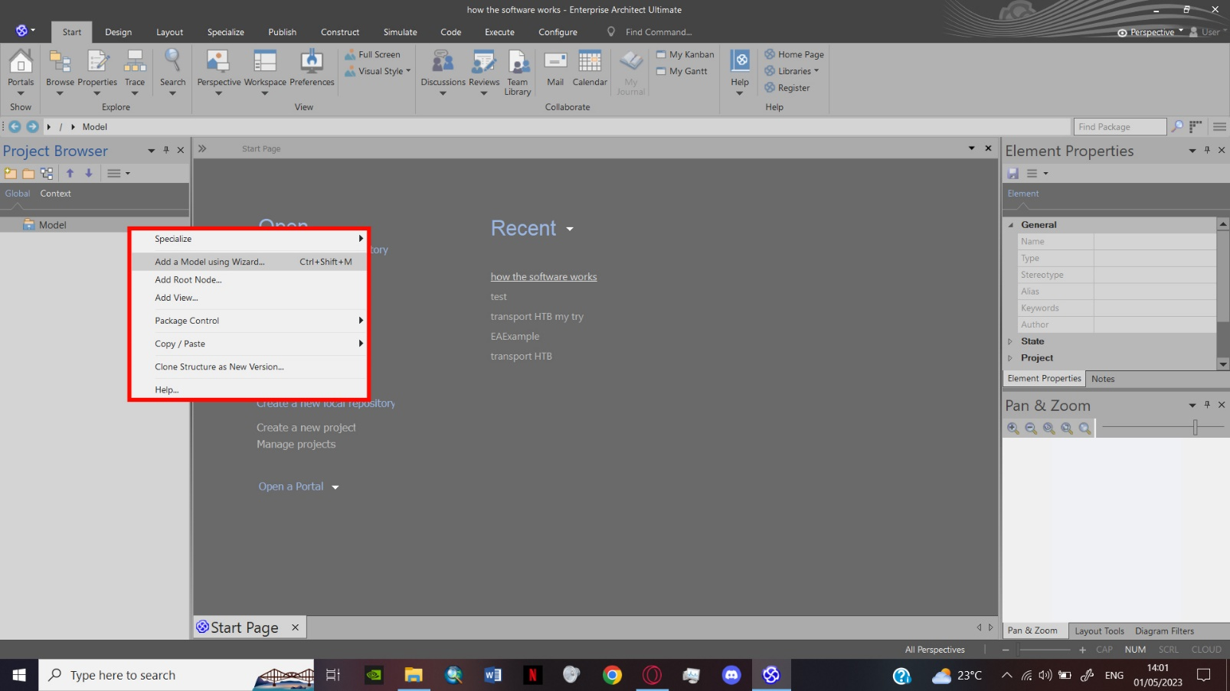

Figure 15: Adding a model

1. Choosing for the ‘Basic PostgresSQL Model’ as the starter model.

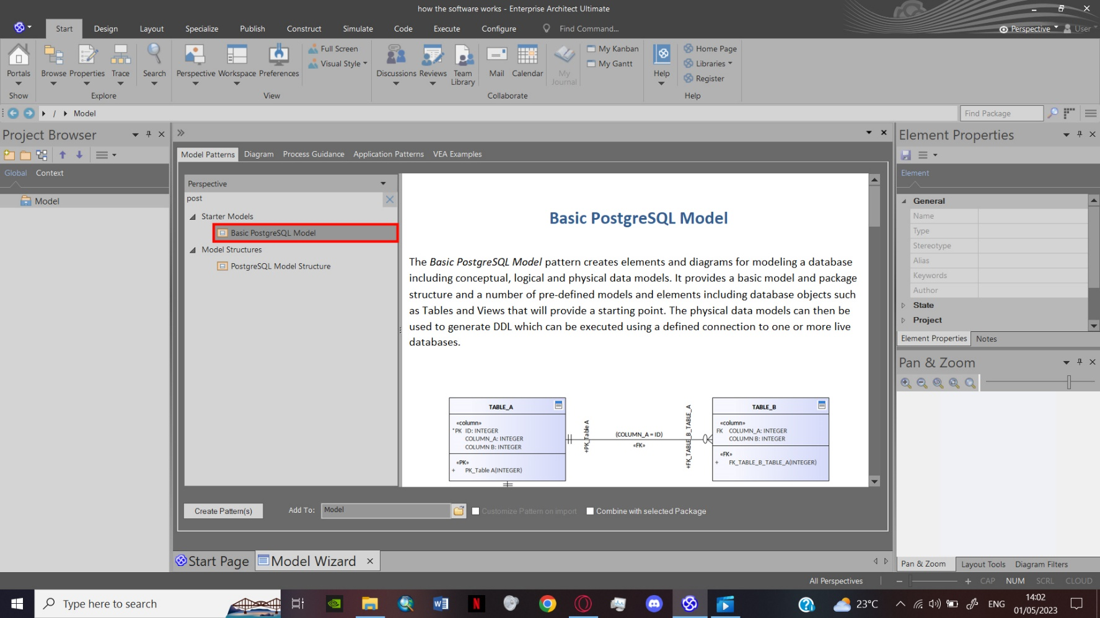

Figure 16:Basic PostgreSQL Model

1. Upon opening the Logical Data Model folder I deleted the default tables.

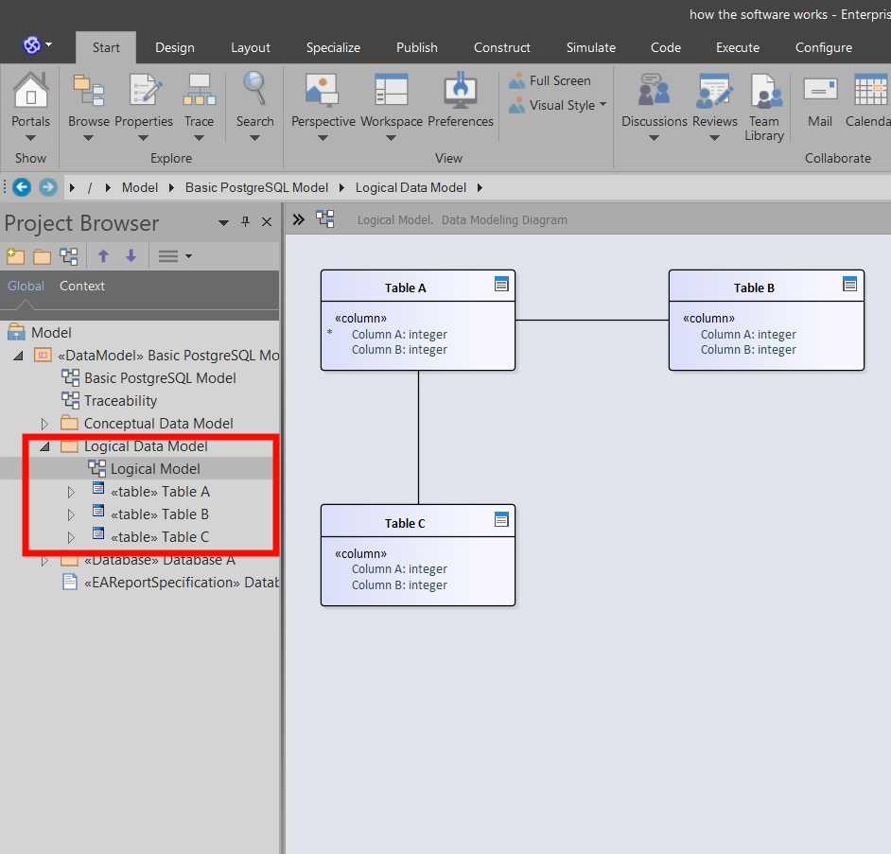

Figure 17: Default Tables

1. 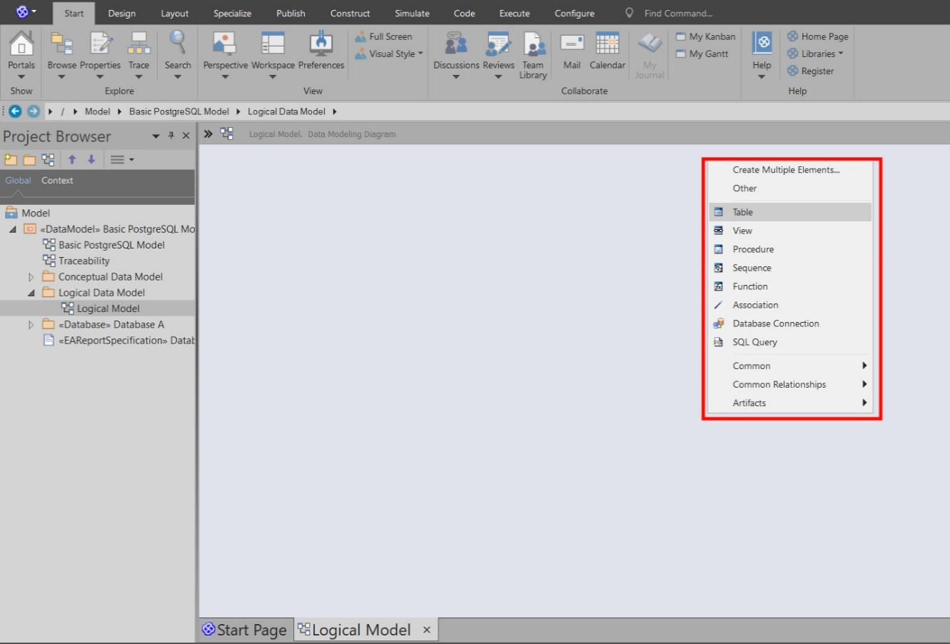I added the new tables by left-clicking and choosing the table feature.

Figure 18: Creating the Tables

1. After creating the 1st table , a left-clicking opens the options where I choose ‘Features’

the command that allows me to choose the DBMS (database managing system ) needed for the task

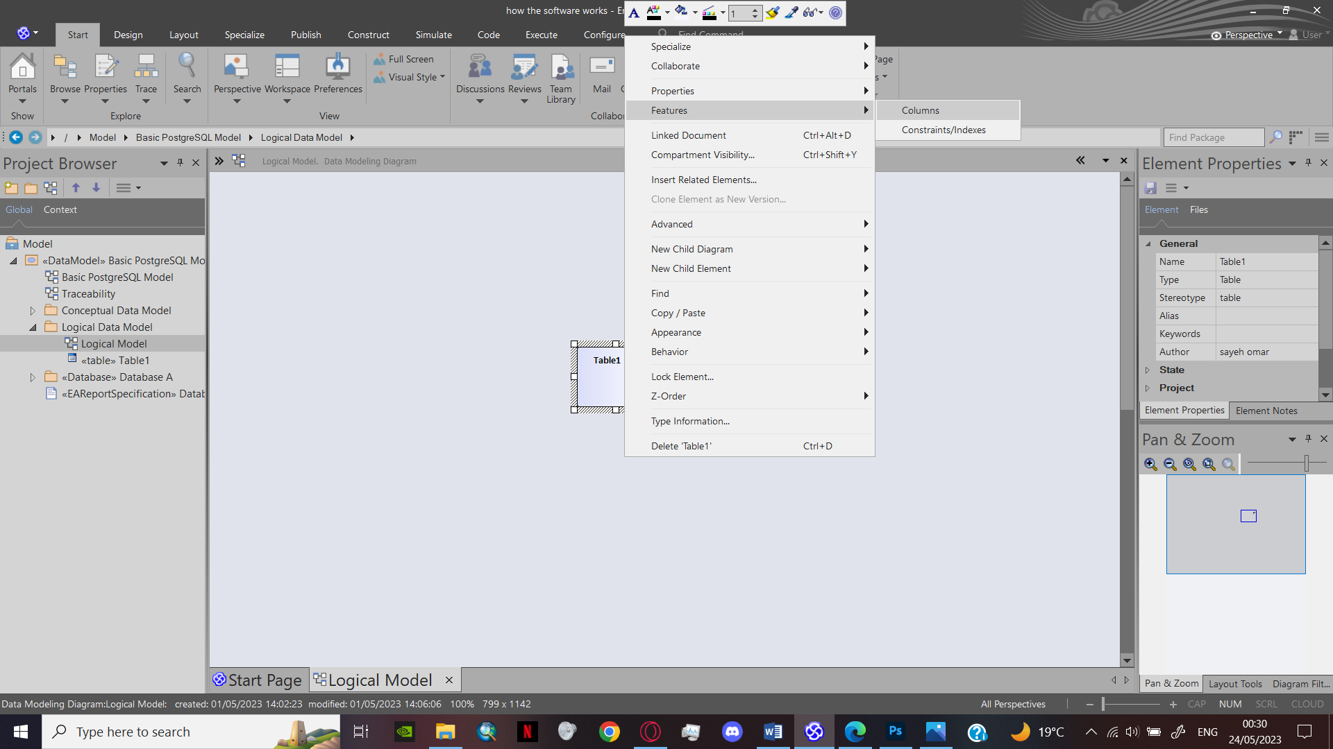

Figure 19: Adding the Features

|  |  |
| --- | --- |
|  | Postgres SQL will be the **DBMS** for our project. |

Figure : Selecting the DBMS PostgreSQL

1. Upon choosing the DBMS, I started creating the features required for each tables basing my work on the data dictionary.

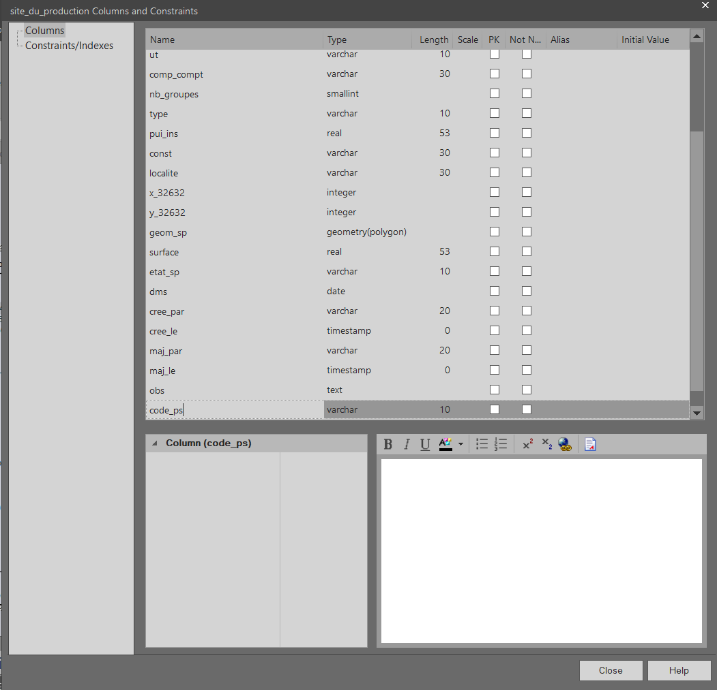

Figure : Example of table with its features

1. After adding the features, I added the constraint that will regulate the management of the data, choosing the name, type and what columns it belongs to.

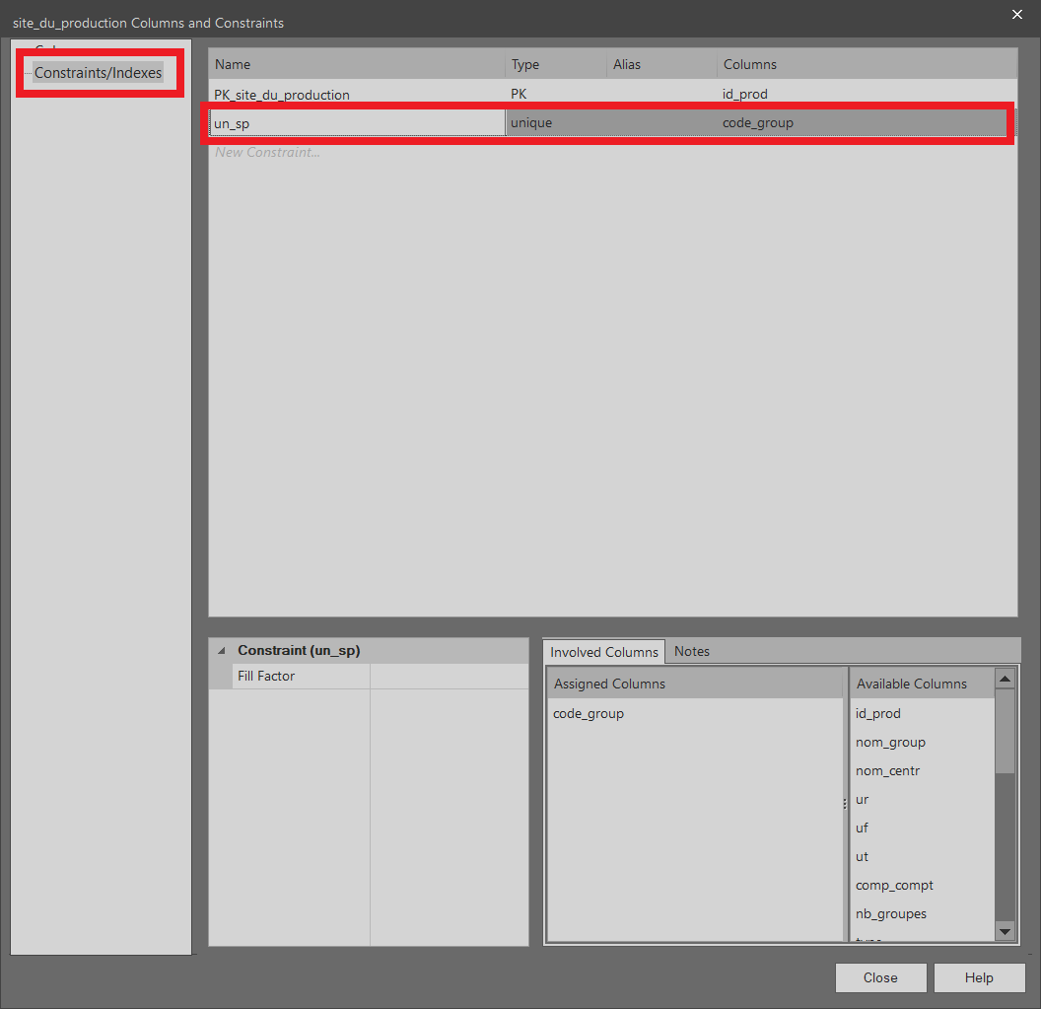

Figure : Adding the constraints

|  |  |
| --- | --- |
| Figure :PK of the site_du_production | Figure :PK and FK of the source_htb |

The PK signifies that the column is a **Primary Key.**

The line under the column has a unique constraint.

1. 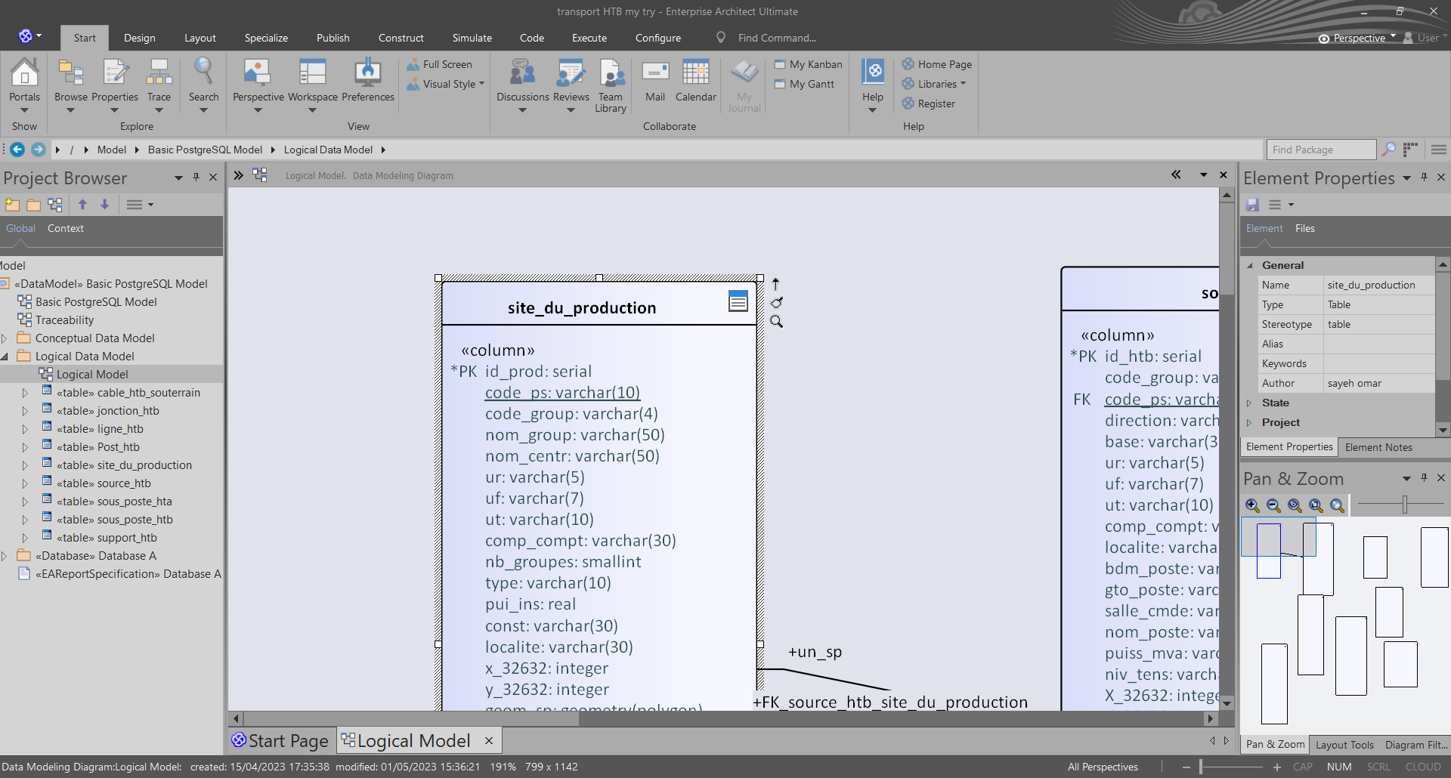To make an association between two tables, a click on the arrow on the up-right of the parent table and drags it to the table we want to associate it with.

Figure : The association arrow

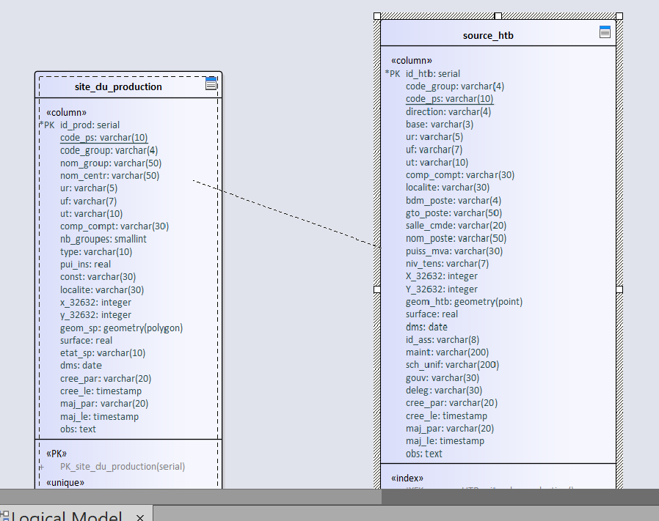

Figure : An association being drawn between two tables

9) A window pops out, we choose the association option.

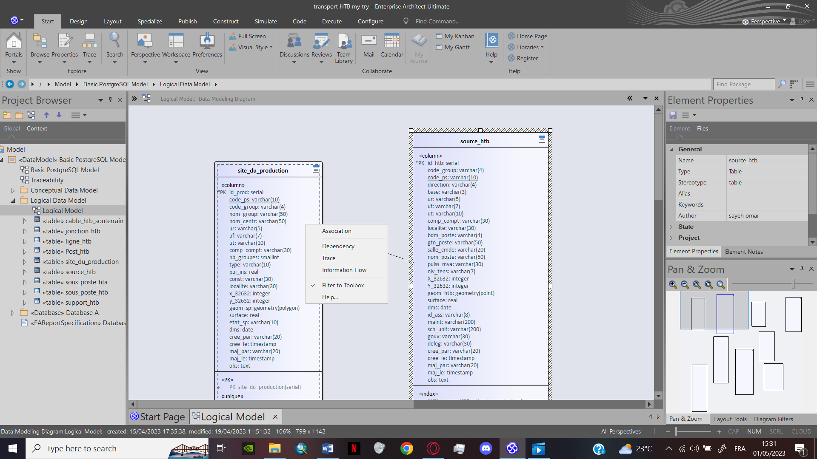

Figure : Association option

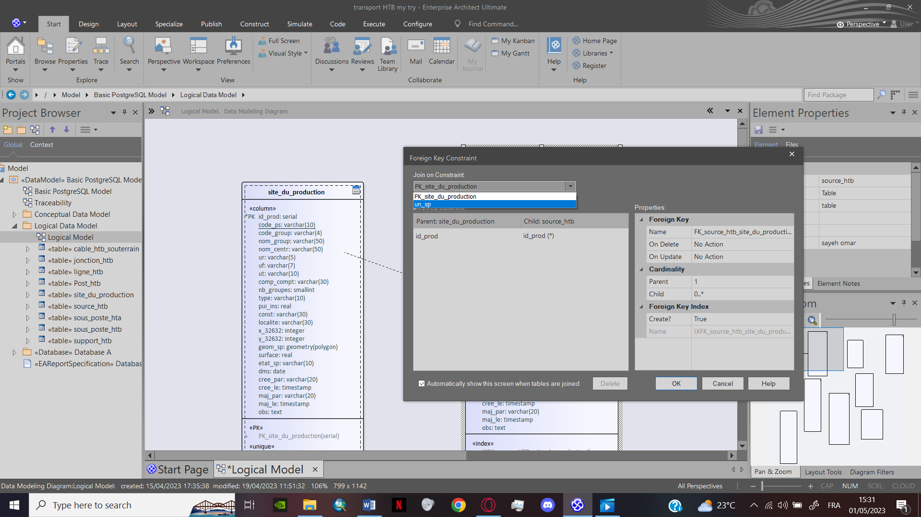10) Upon confirming the association, we choose the ‘join on constraint’ then we confirm what columns are going to be the FK (foreign keys).

Figure :Foreign key Constraint

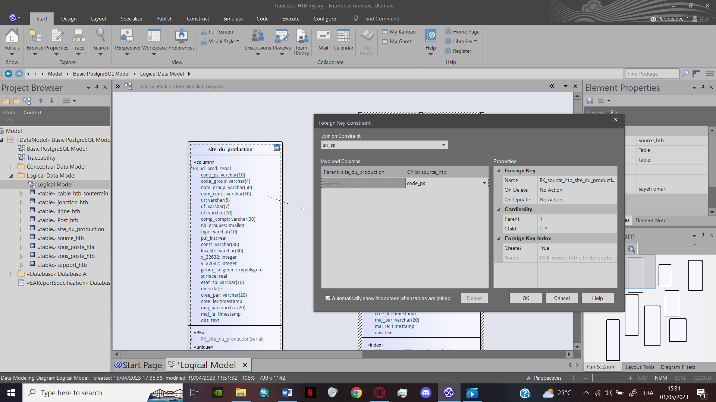un_sp is the name of the constraint we defined for (site_du_production) and (source_htb).

Figure : Foreign key Constraint

When choosing the un_sp the software changes the columns to the ones we defined earlier

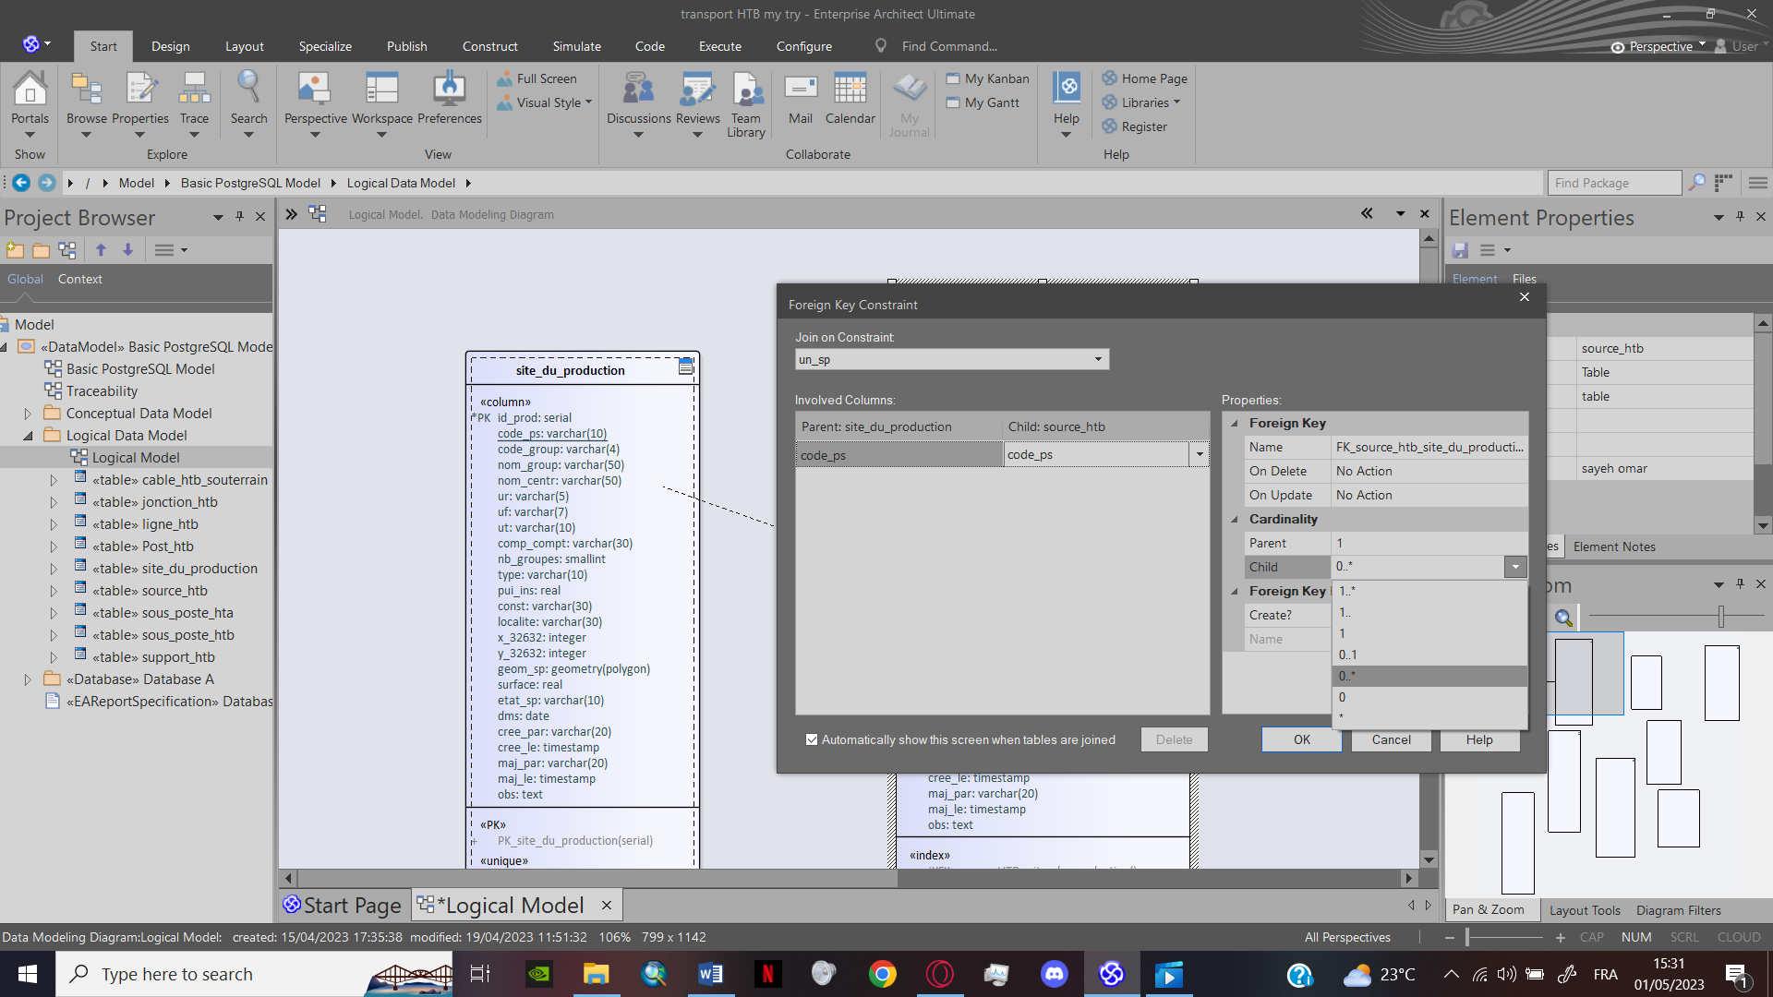

Figure : Type of Cardinalities

At this stage of the process we define the cardinality of the association

For this example we choose (**0..\***) or (**0 to many** ) which signifies that the(**site_du_production**) is providing electricity to different (**source_htb**) but the (**source_htb**) can only relate to one (**site_du_production**).

The 0 in the cardinality signifies that a (site_du_production) can be under construction or not yet exciting.

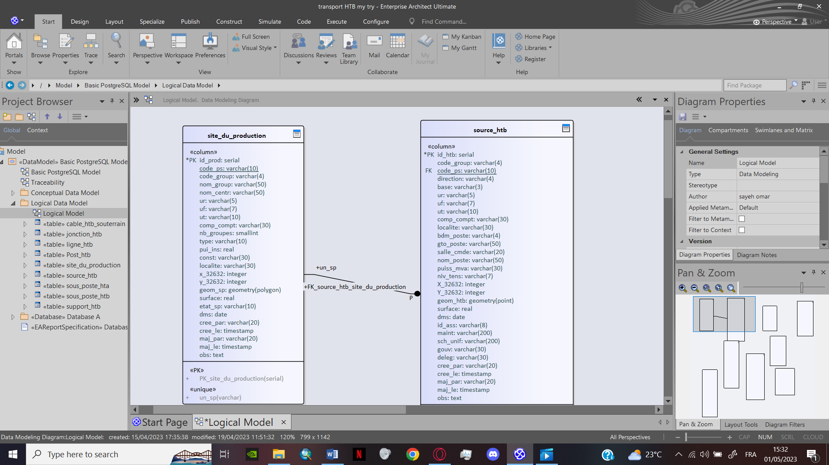**The result:**

Figure : An association has been created

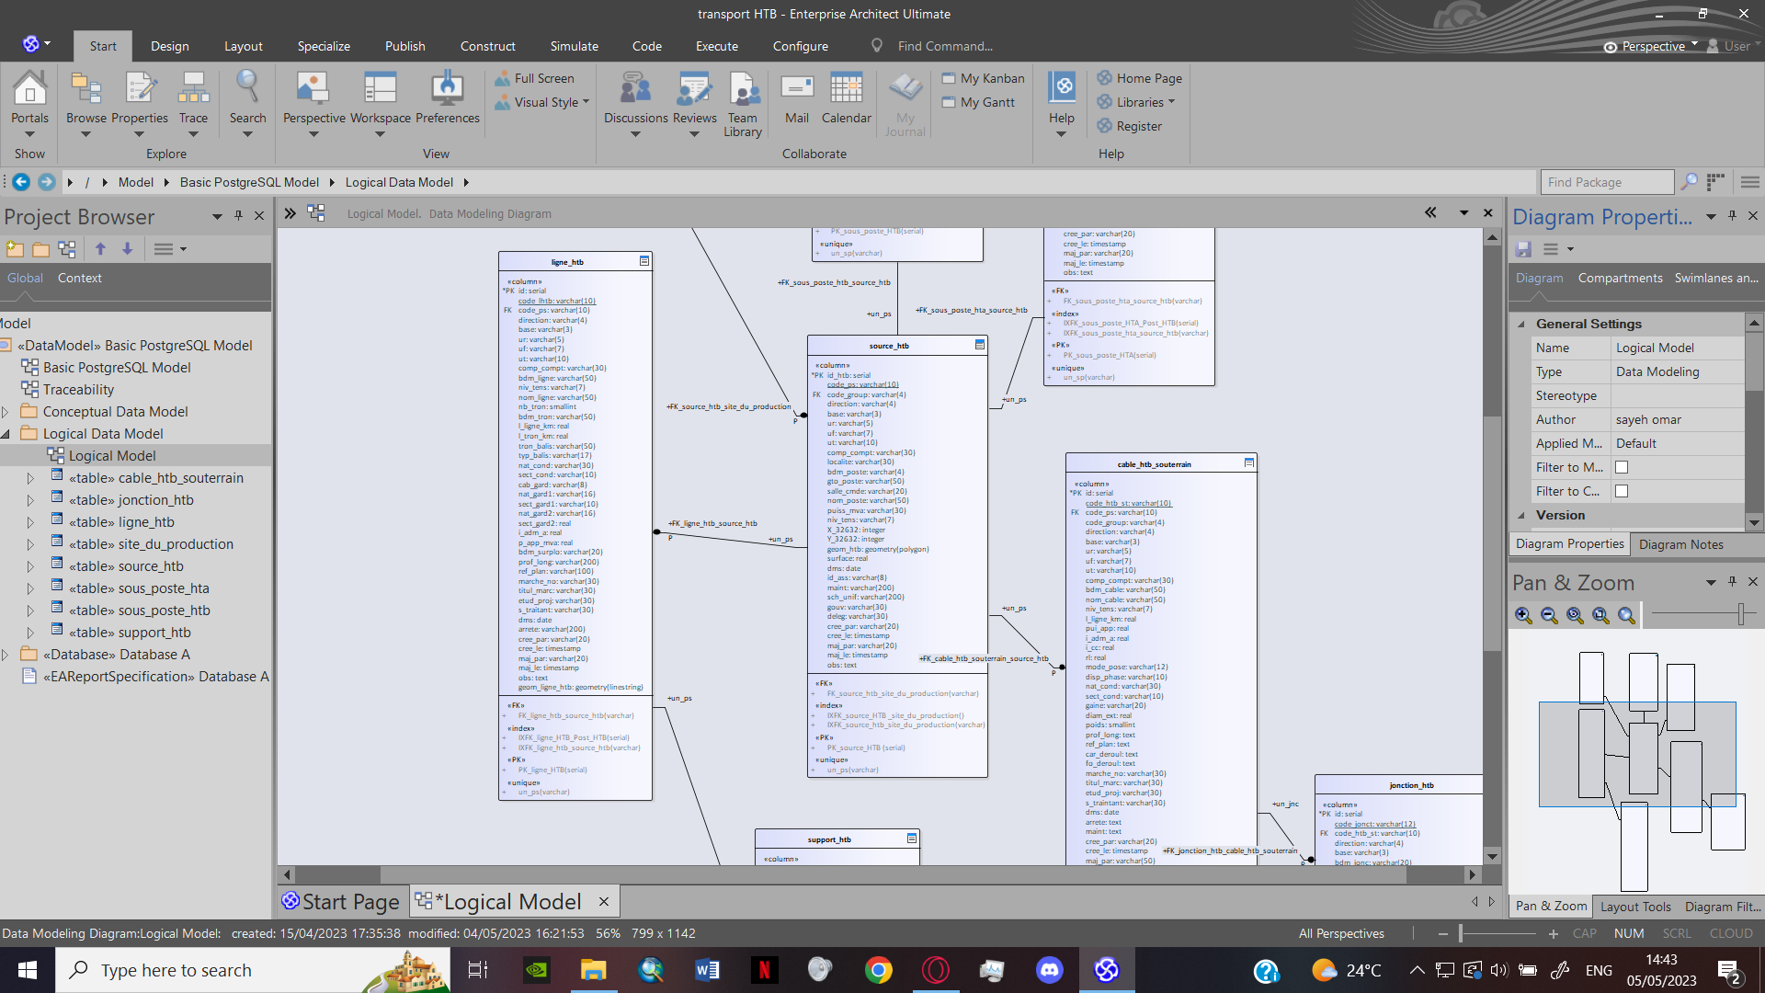

Figure : The different association between the tables

## SQL code generation:

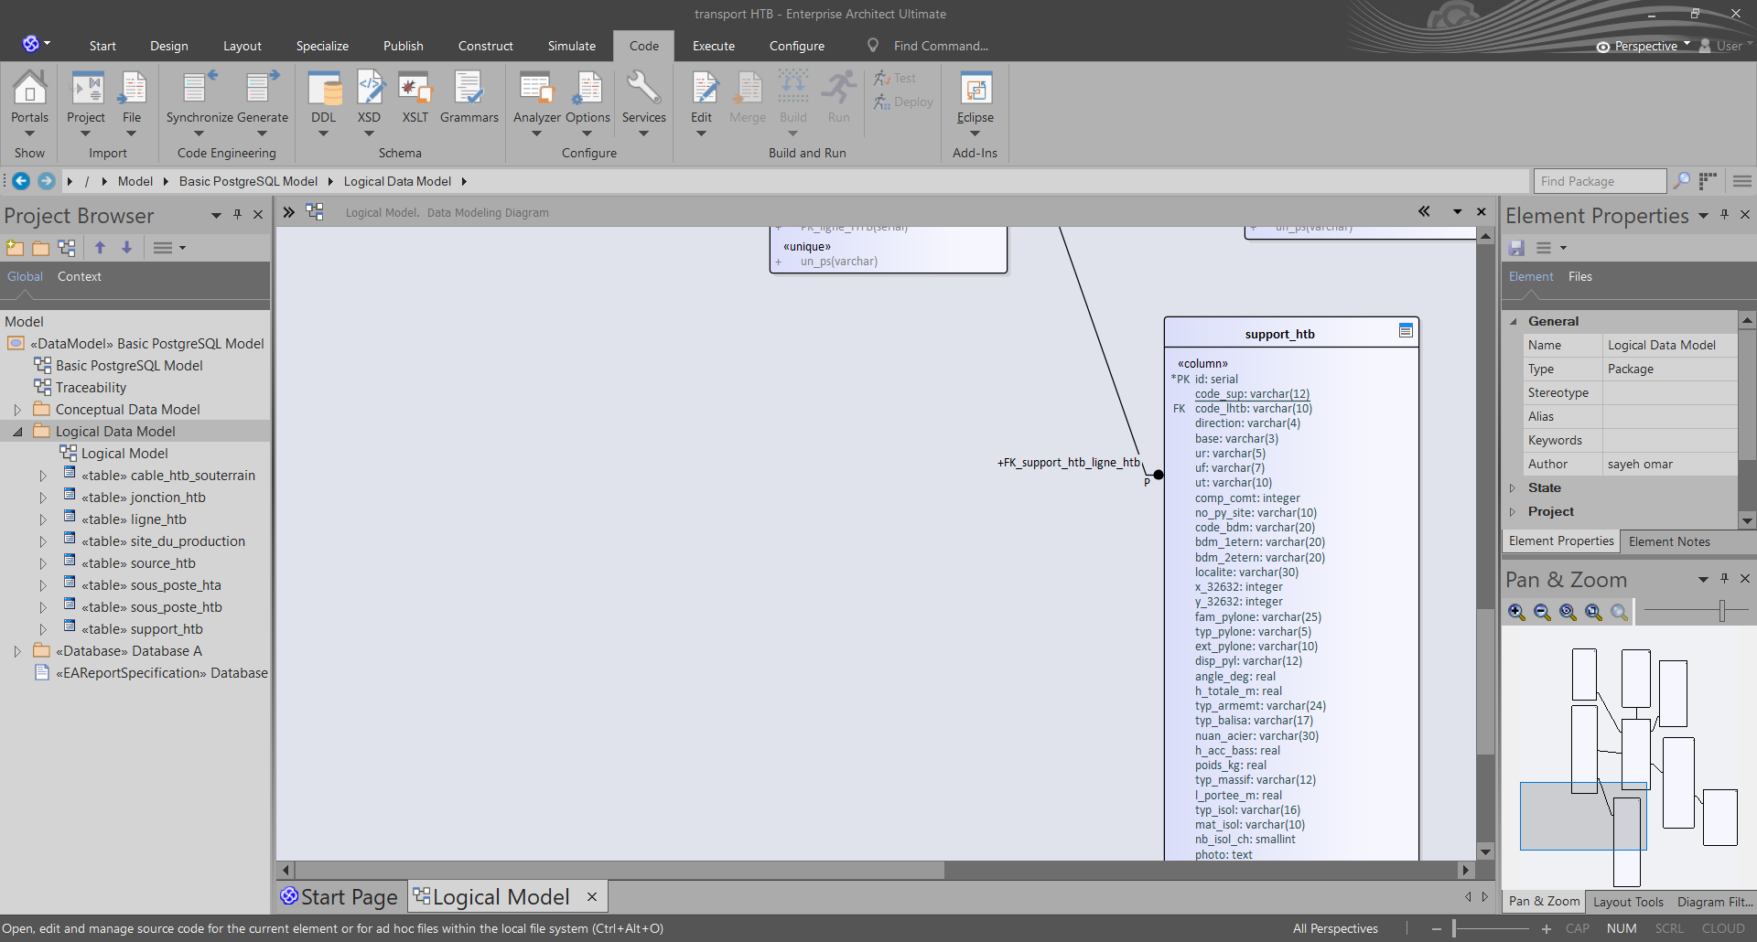1) On the bar menu we access the code tab

Figure : Task bar - DDL

Figure : Task bar -Code

Then we choose the DDL on the Schema category

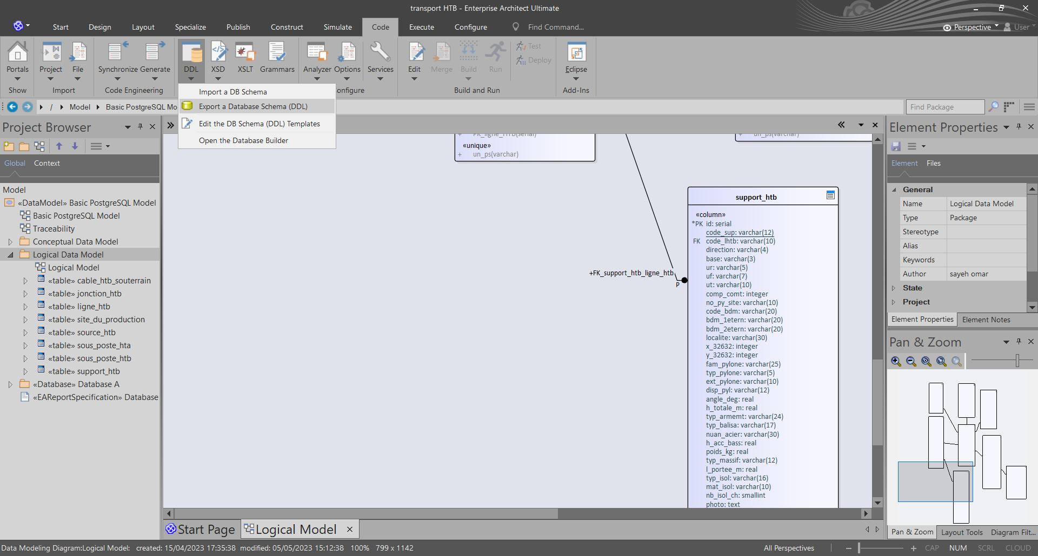2) We choose (export a Database Schema DDL)

Figure : Exporting the database schema

3) In the Generate DDL window, we select all the tables that forms the database

Upon doing that we confirm the trajectory in where the file is going to be saved with the **single file** option checked.

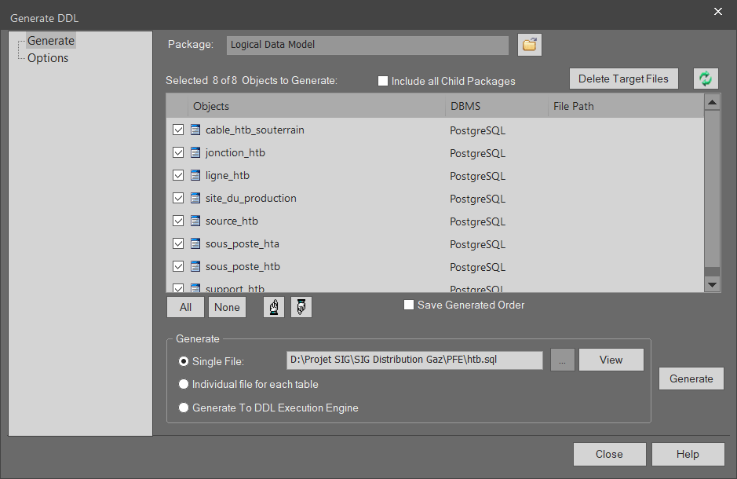

Figure : Generate DDL window

## Creation of the drop-list for the type of the features:

### Visual studio code:



Figure : Visual Studio Code’ logo

Visual StudioCode, also commonly referred to as VS Code, is a [source-code editor](https://en.wikipedia.org/wiki/Source-code_editor) made by [Microsoft](https://en.wikipedia.org/wiki/Microsoft) with the [Electron Framework](https://en.wikipedia.org/wiki/Electron_(software_framework)), for [Windows](https://en.wikipedia.org/wiki/Windows), [Linux](https://en.wikipedia.org/wiki/Linux) and [macOS](https://en.wikipedia.org/wiki/MacOS).

 Features include support for [debugging](https://en.wikipedia.org/wiki/Debugging), [syntax highlighting](https://en.wikipedia.org/wiki/Syntax_highlighting), [intelligent code completion](https://en.wikipedia.org/wiki/Intelligent_code_completion), [snippets](https://en.wikipedia.org/wiki/Snippet_(programming)), [code refactoring](https://en.wikipedia.org/wiki/Code_refactoring), and embedded [Git](https://en.wikipedia.org/wiki/Git). Users can change the [theme](https://en.wikipedia.org/wiki/Theme_(computing)), [keyboard shortcuts](https://en.wikipedia.org/wiki/Keyboard_shortcut), preferences, and install [extensions](https://en.wikipedia.org/wiki/Plug-in_(computing)) that add functionality.

### SQL:

Structured Query Language, abbreviated as SQL, is a [domain-specific language](https://en.wikipedia.org/wiki/Domain-specific_language) used in programming and designed for managing data held in a [relational database management system](https://en.wikipedia.org/wiki/Relational_database_management_system) (RDBMS), or for stream processing in a [relational data stream management system](https://en.wikipedia.org/wiki/Relational_data_stream_management_system) (RDSMS). It is particularly useful in handling [structured data](https://en.wikipedia.org/wiki/Data_model), i.e. data incorporating relations among entities and variables. (10)

### The script:

To avoid mistakes and to make the creation of the shape files easier we had to add drop lists to certain features in certain tables, these features were usually either pre-defined codes for locations, sites, GIS related or simply different degrees of voltages.

To add a drop-list to a table first we must define the entities of the feature:

**CREATE TYPE public.feature_name as ENUM (**

**Option a,**

**Option b,**

**Option c**

**);**

**ALTER TABLE public.feature_name OWNER TO Postgres;**

For example:

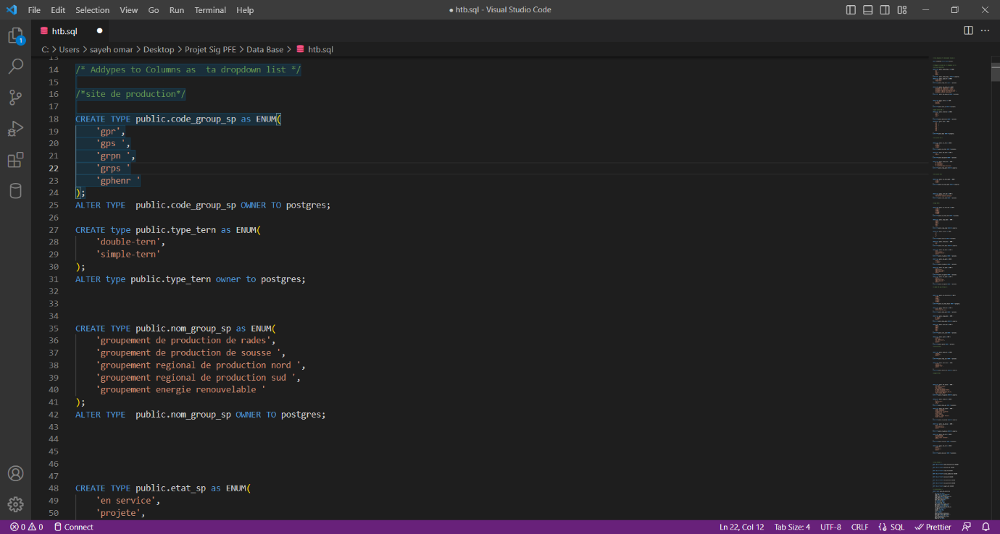

Figure : A drop-list for the regional groups

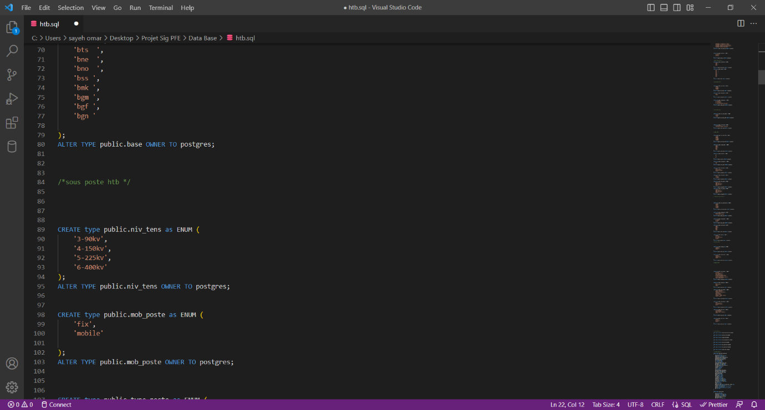

Figure : A drop-list for the code group

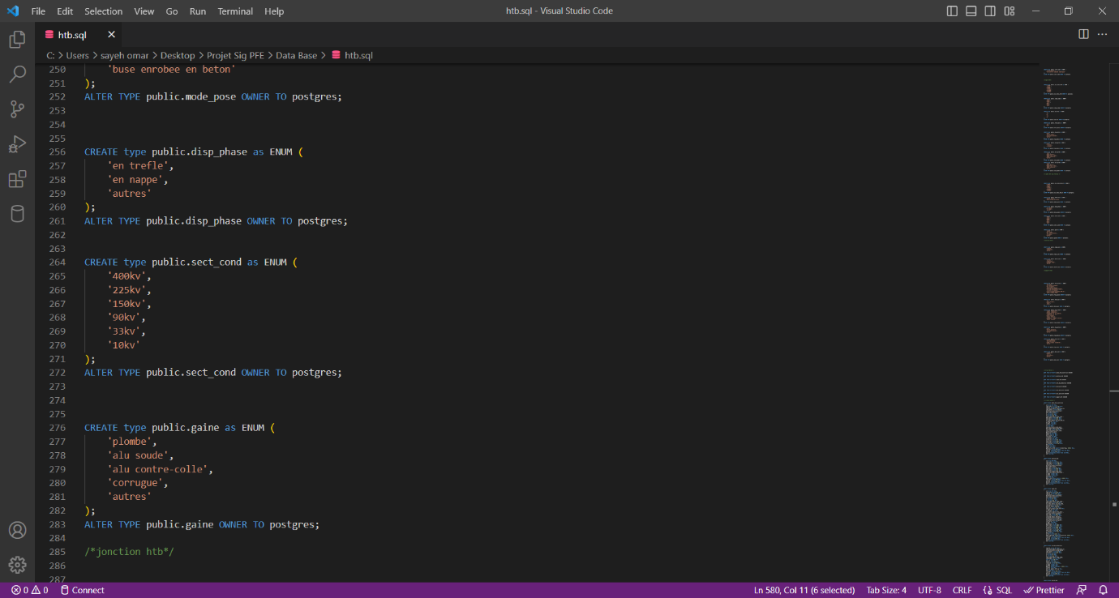

Figure : A drop-list for the different degrees of voltages

## Integration into the geo-spatial database (PostgresSQL, PostGIS):

### Setting up the environment:

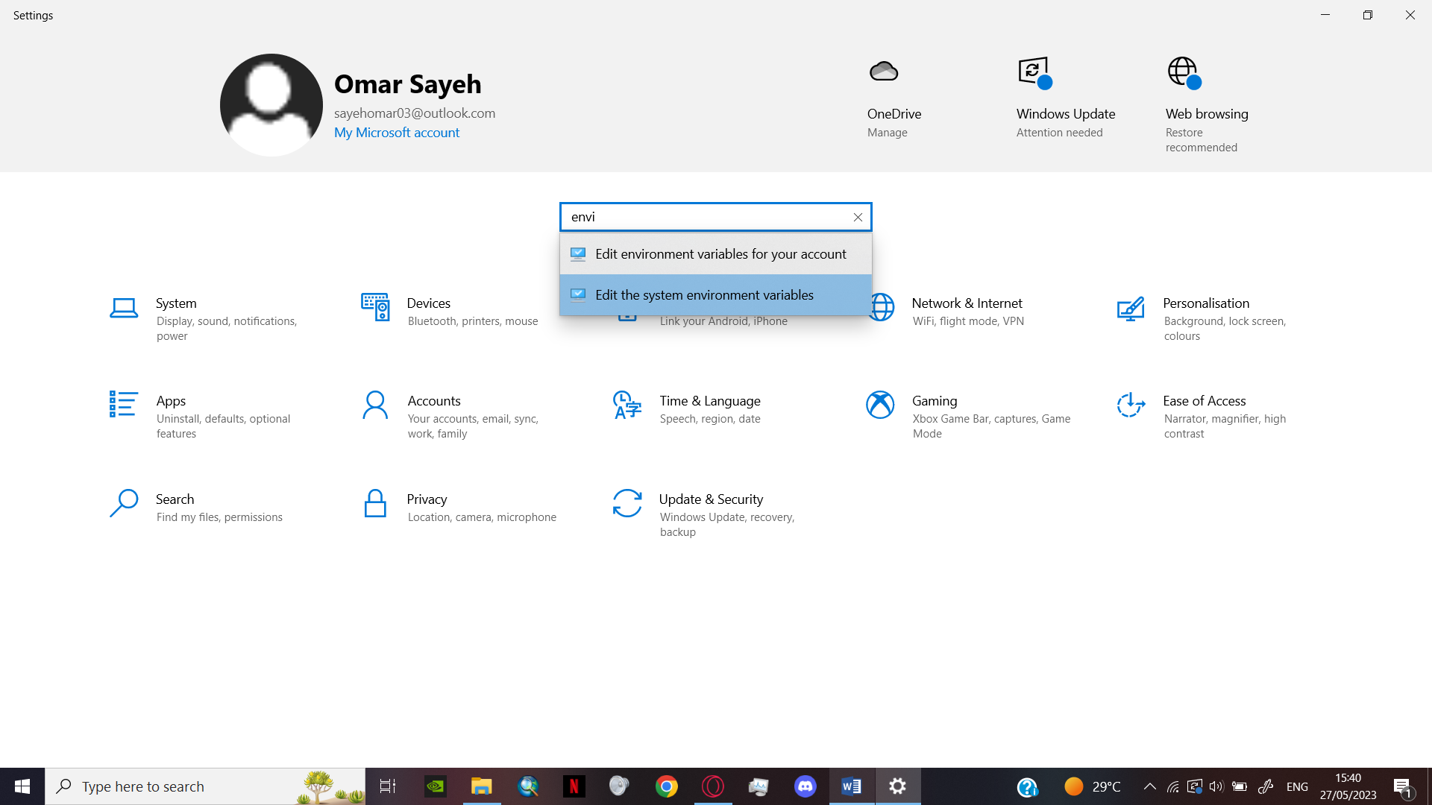1) In the computer settings search for ‘edit the system environment variables’.

Figure :Settings window

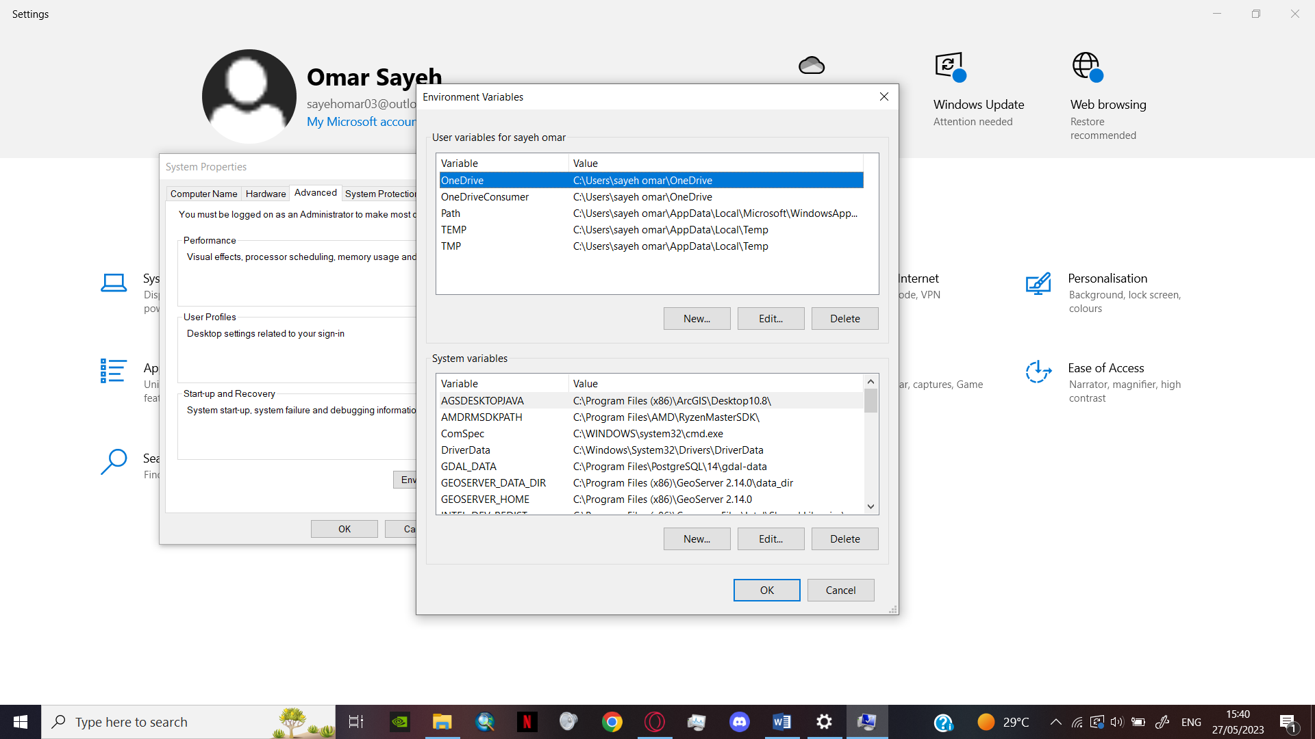2) In the system properties, press the environment button to open the environment variables window.

Figure : Environment variables

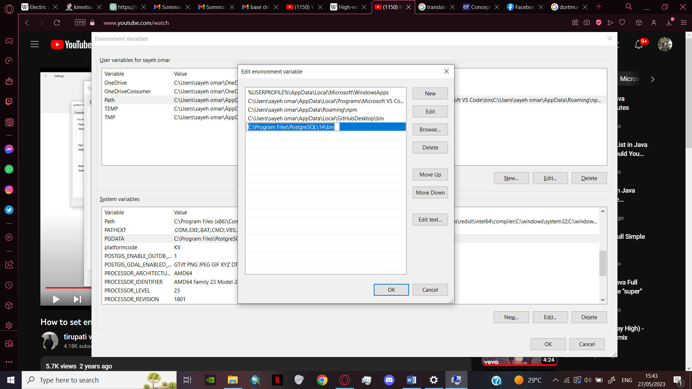3) In the ‘edit environment variable’ window add the path to the bin of the PostgresSQL directory.

Figure : Edit environment variable

4) In the ‘edit system variable’ window add the path to the data of the PostgresSQL directory.

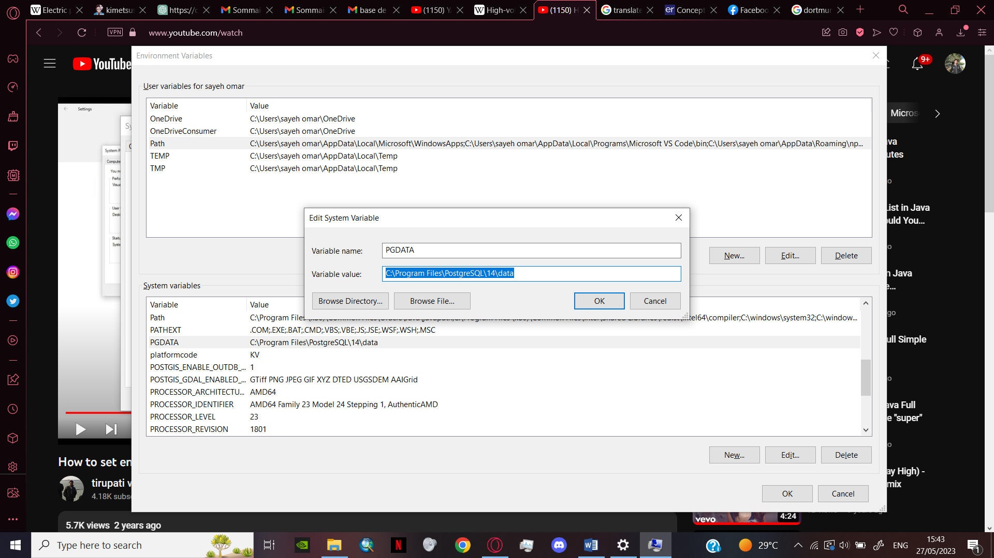

Figure : Edit system variable

### Integration with terminal command (cmd):

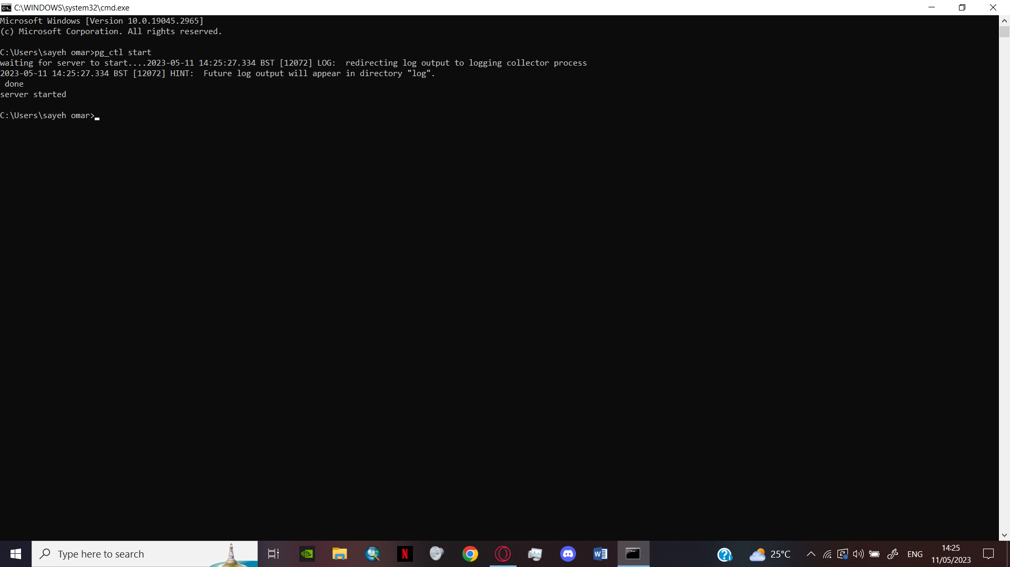1) To start the server, I used the command (pg_ctl start) that allows me initialize, start, stop, or control a PostgresSQL server.

Figure : Starting the PostgreSQL server

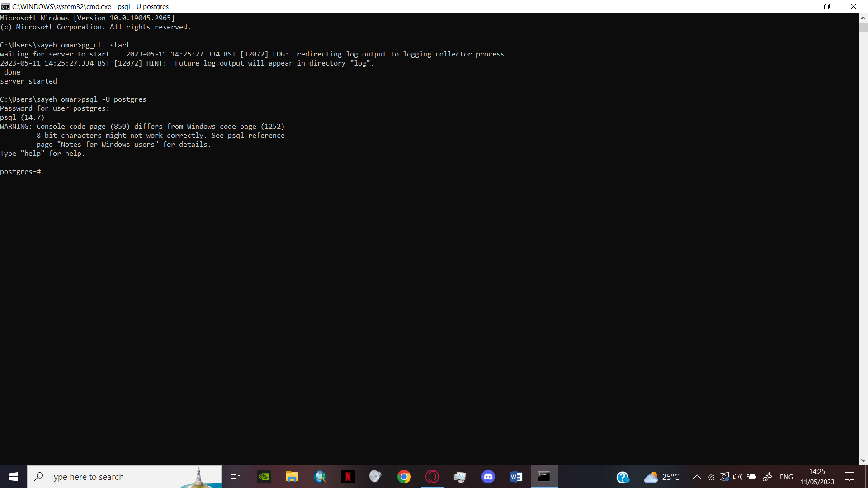2) To access the PostgresSQL, I used the command (psql –U postgres) that allows me to access the PostgresSQL server as the user ‘postgres’. (The password is required)

Figure : Entering the user name and the password

3) To create the data base, I used the command (**CREATE DATABASE** data_base_name;)

To view the data base, I used the command ( **\LIST** )

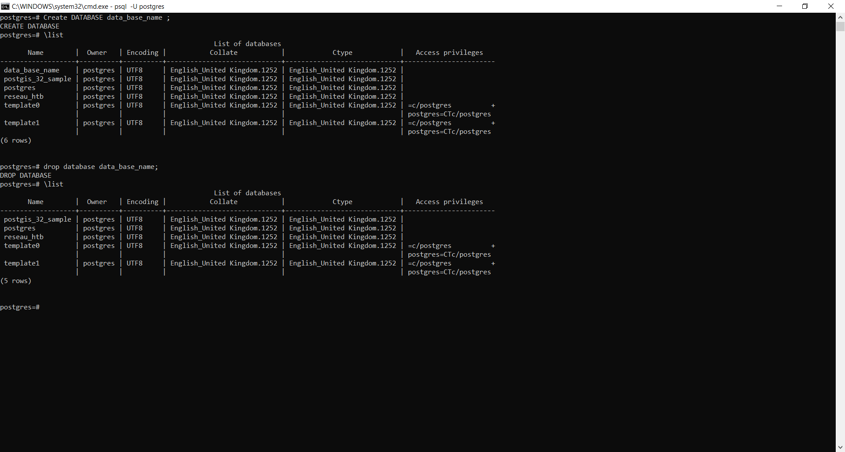To erase a database I used the command (**DROP DATABASE** data_base_name;)

Figure : Creating/Inspecting/Deleting a database

4) For the project I will be using the database (reseau_htb), to inject the sql code to the database first I used the command (\**C** reseau_htb) to switch to the (reseau_htb) then use the command ( **\I** ‘C:/Users/sayeh omar/Desktop/Projet Sig PFE/Data Base/htb.sql’)

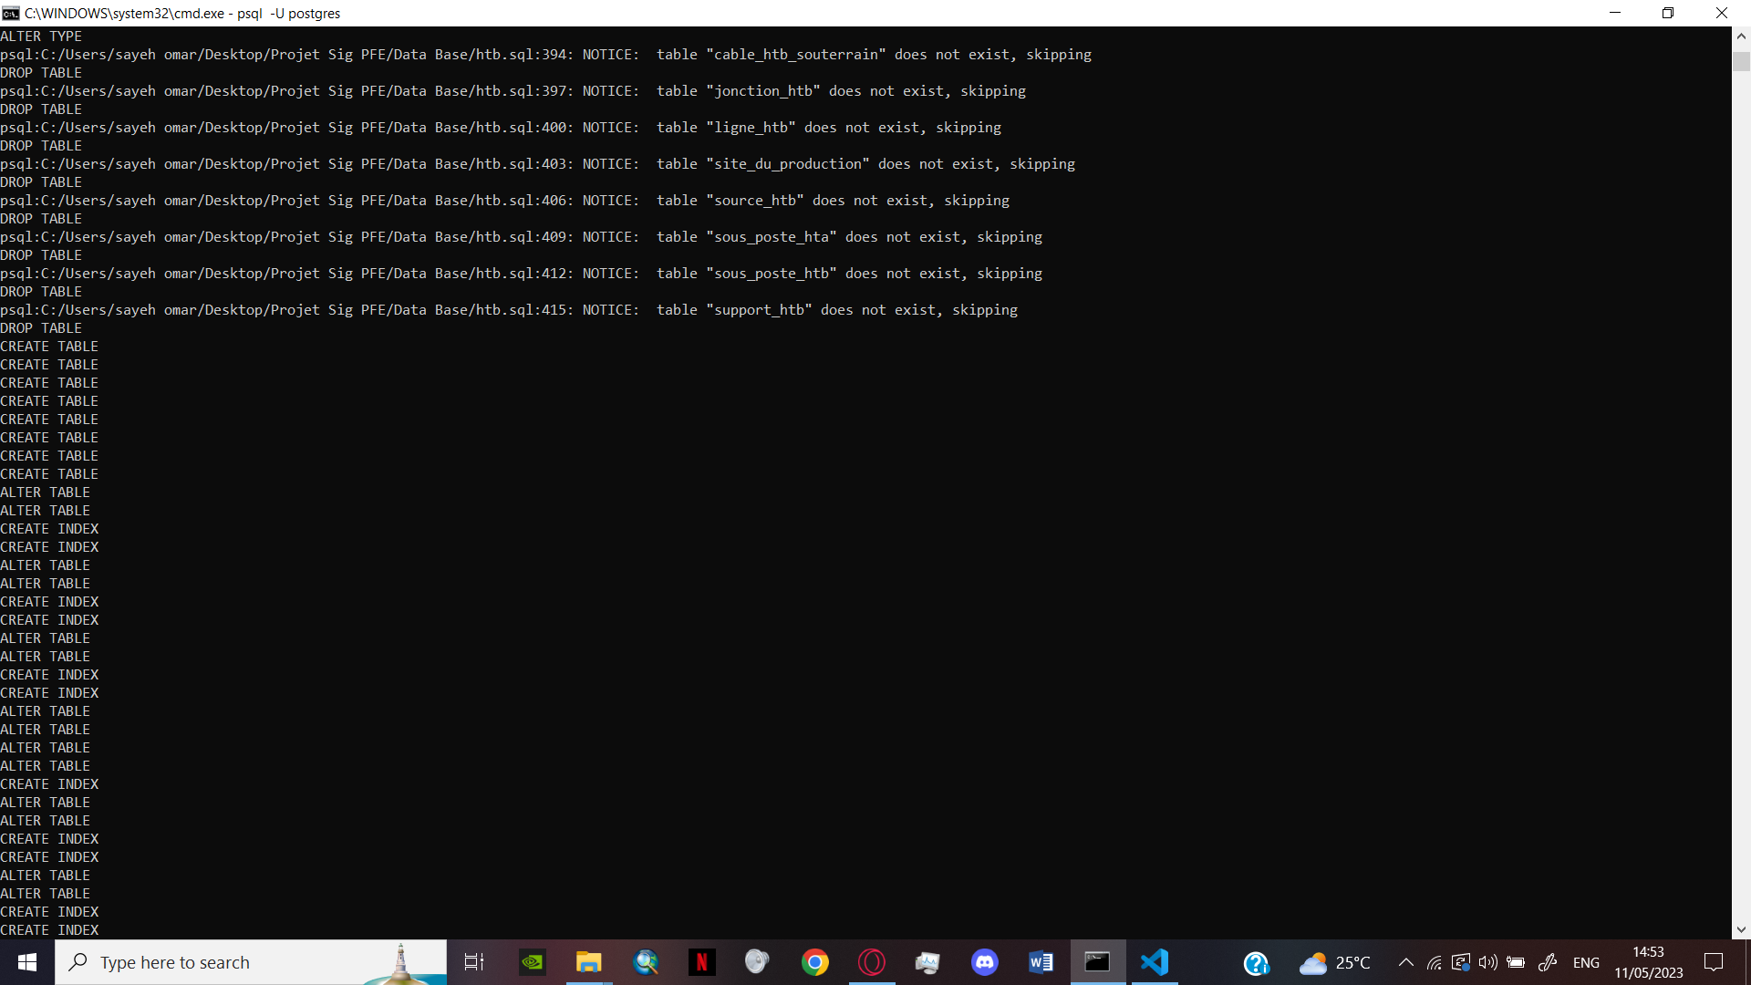  
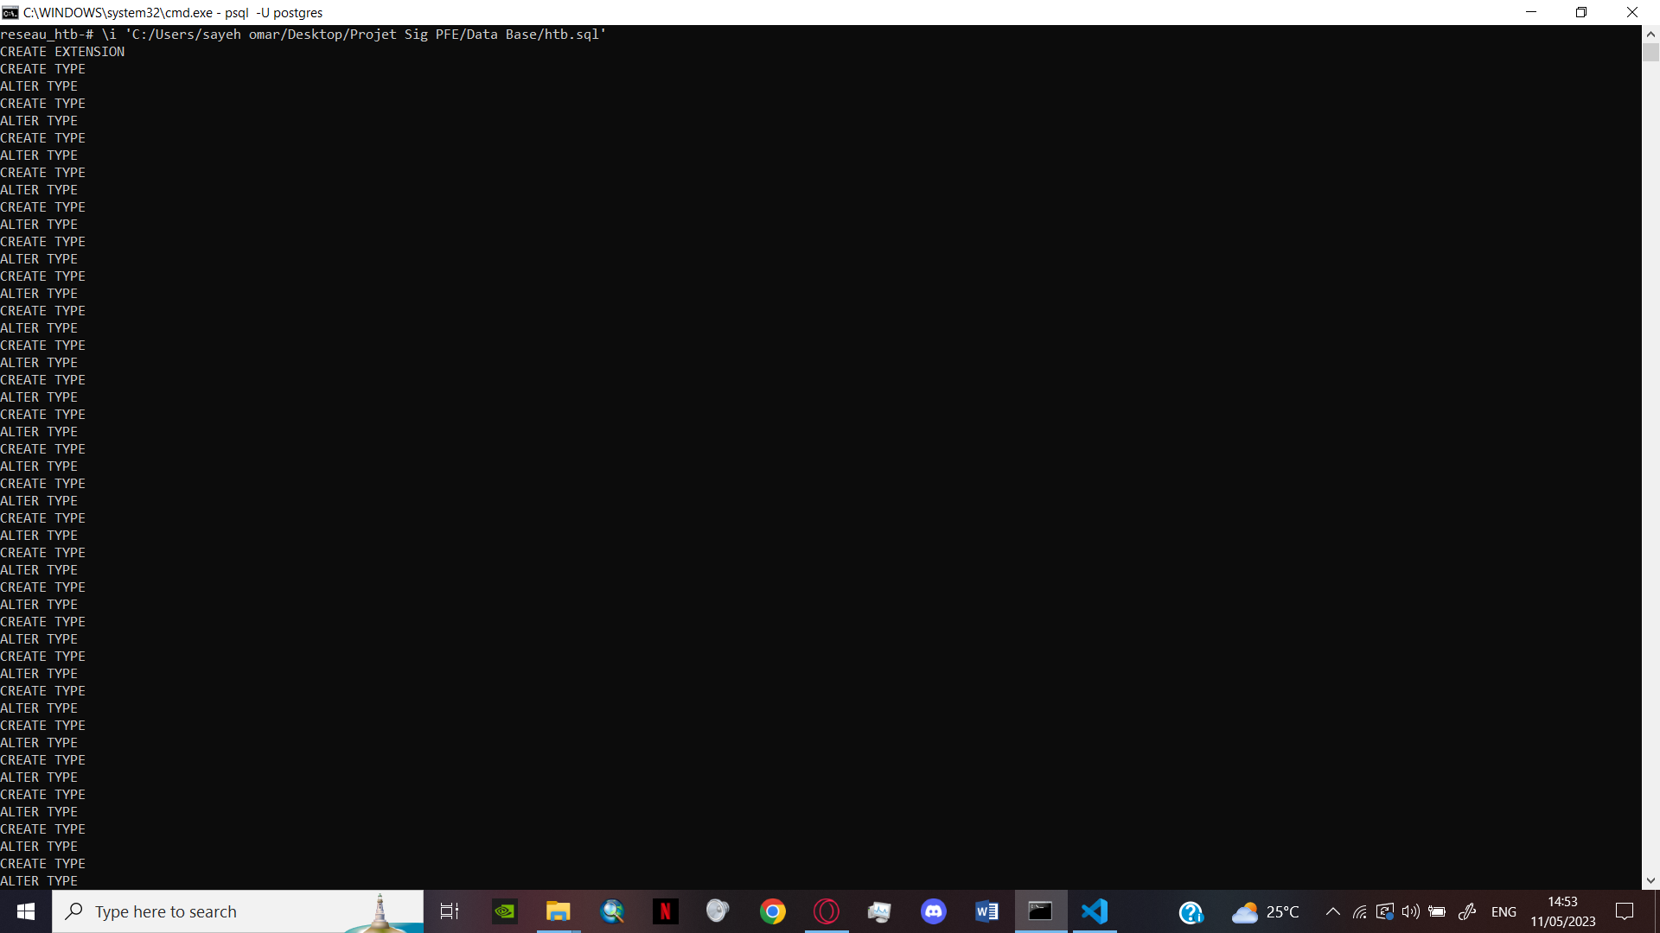

Figure : The SQL code being injected

Figure : Injecting the SQL into the database reseau_htb

# Workflow between QGIS and postgresql/postgis:

## What is QGIS :

QGIS is a [free](https://en.wikipedia.org/wiki/Free_software) and [open-source](https://en.wikipedia.org/wiki/Open-source_software) [cross-platform](https://en.wikipedia.org/wiki/Cross-platform) desktop [geographic information system](https://en.wikipedia.org/wiki/Geographic_information_system) (GIS) application that supports viewing, editing, printing, and analysis of geospatial data.   
  
QGIS functions as [geographic information system](https://en.wikipedia.org/wiki/Geographic_information_system) (GIS) software, allowing users to analyse and edit spatial information, in addition to composing and exporting graphical maps. QGIS supports [raster](https://en.wikipedia.org/wiki/Raster_graphics), [vector](https://en.wikipedia.org/wiki/Vector_graphics) and mesh layers. Vector data is stored as either point, line, or [polygon](https://en.wikipedia.org/wiki/Polygon_(computer_graphics)) features. Multiple formats of raster images are supported, and the software can [georeference](https://en.wikipedia.org/wiki/Georeferencing) images.



Figure : QGIS LOGO

QGIS supports [shape files](https://en.wikipedia.org/wiki/Shapefile), personal geodatabases, [dxf](https://en.wikipedia.org/wiki/Dxf), [MapInfo](https://en.wikipedia.org/wiki/MapInfo_Professional), [PostGIS](https://en.wikipedia.org/wiki/PostGIS), and other industry-standard formats. Web services, including [Web Map Service](https://en.wikipedia.org/wiki/Web_Map_Service) and [Web Feature Service](https://en.wikipedia.org/wiki/Web_Feature_Service), are also supported to allow use of data from external sources.

QGIS integrates with other open-source GIS packages, including PostGIS, GRASS GIS, and MapServer. Plugins written in Python or C++ extend QGIS's capabilities. Plugins can geocode using the Google Geocoding API, perform geoprocessing functions similar to those of the standard tools found in ArcGIS, and interface with PostgreSQL/PostGIS, SpatiaLite and MySQL databases. (11)

## Connection between POSTGRESQL/QGIS:

The connection between PostgreSQL and QGIS enables the exchange of spatial data between the two systems, allows for work with geographic information in a database environment and a GIS software.

1) To connect the POSTGRESQL to QGIS, I opened the PostgreSQL window from the data source manager, then create a new connection PostGIS by entering the name of the user, the host, the database and the port. (Password is required)

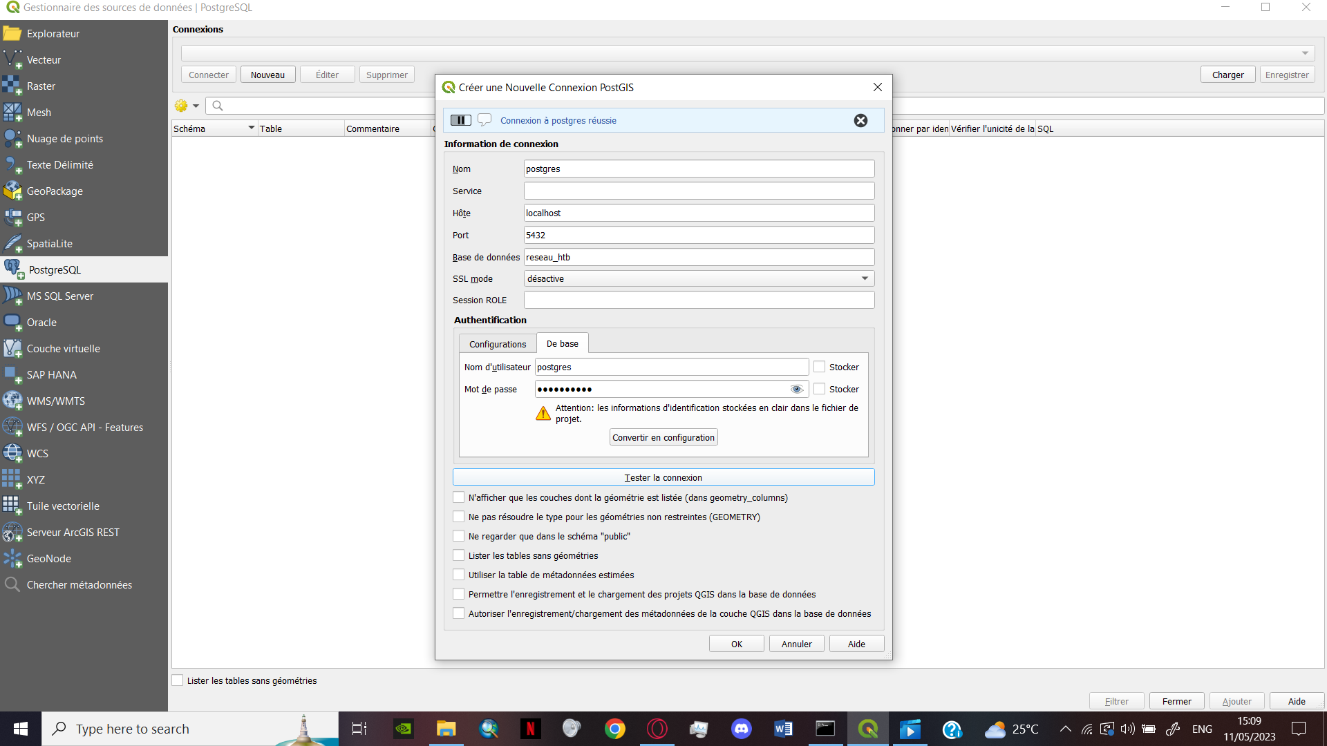

Figure : New Connection PostGIS window

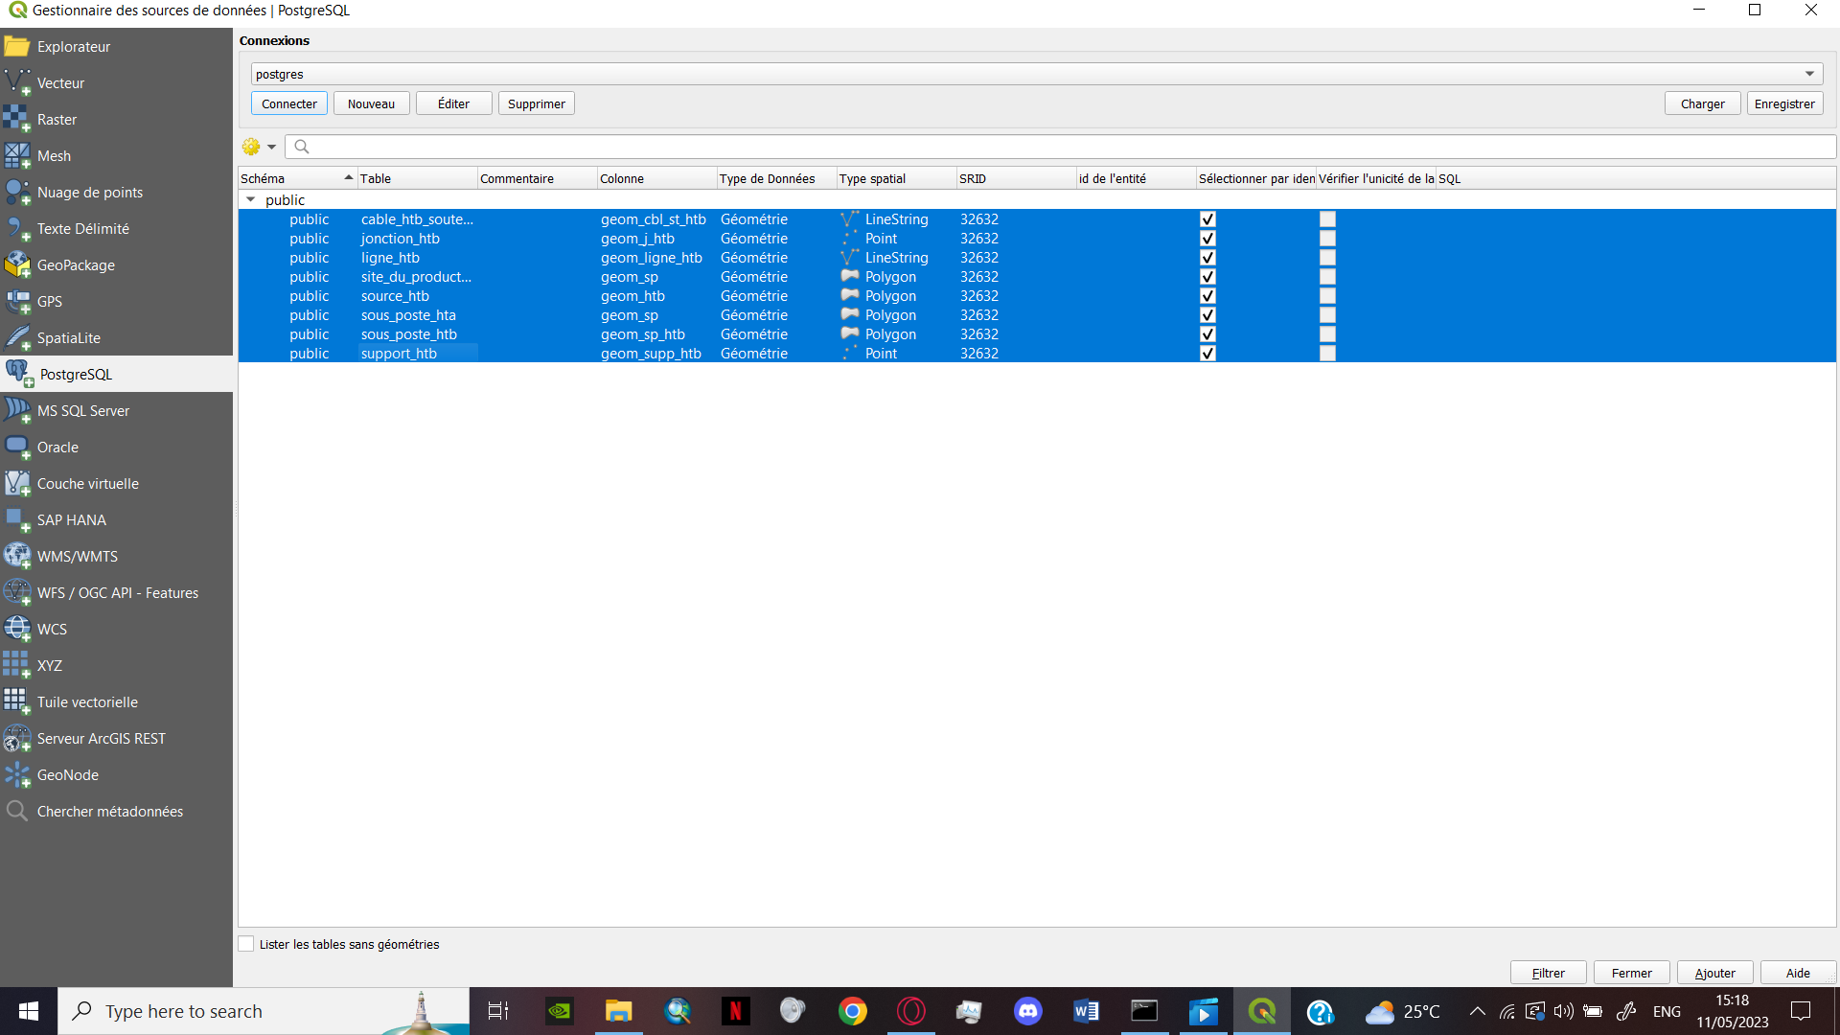2) Upon connecting the database to the Qgis, I imported the tables by pressing the connecting button

Figure : The tables brought to QGIS

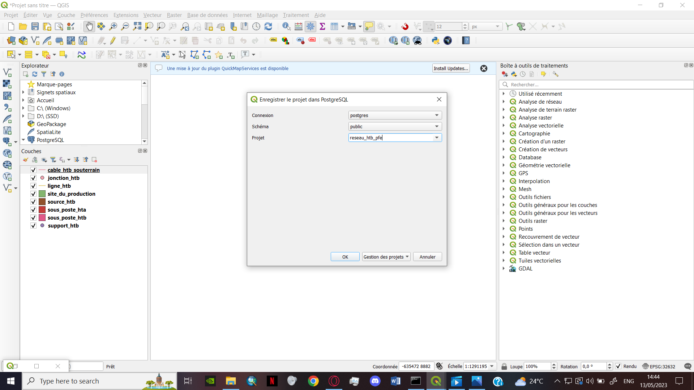

Figure : The Tables as geospatial layers

## Development of symbology and labels for each table:

For better distinguishing the different elements of the tables a symbology had to be made based on specific queries.

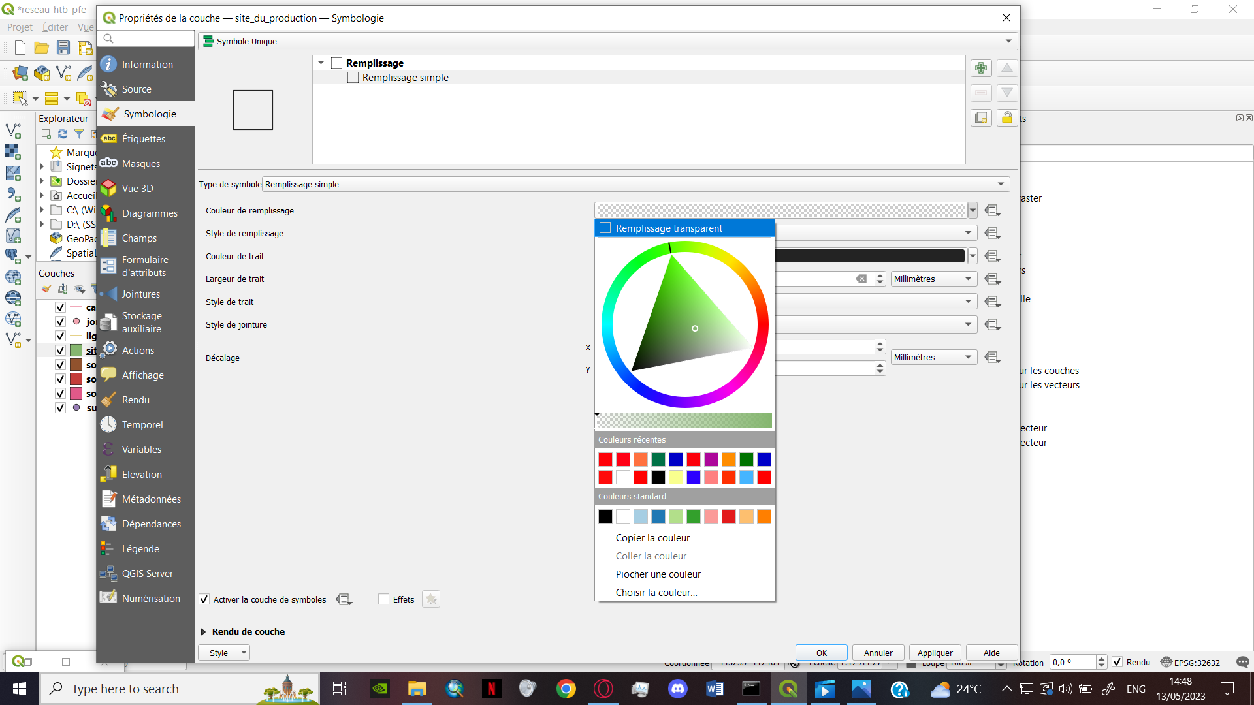1) To open the symbology section, I double clicked on the layer.

Figure : The symbology window

2) For simpler design I choose (single symbol)

3) After choosing the right category, I customized the settings to match the dictionary of data

Figure : unique symbol

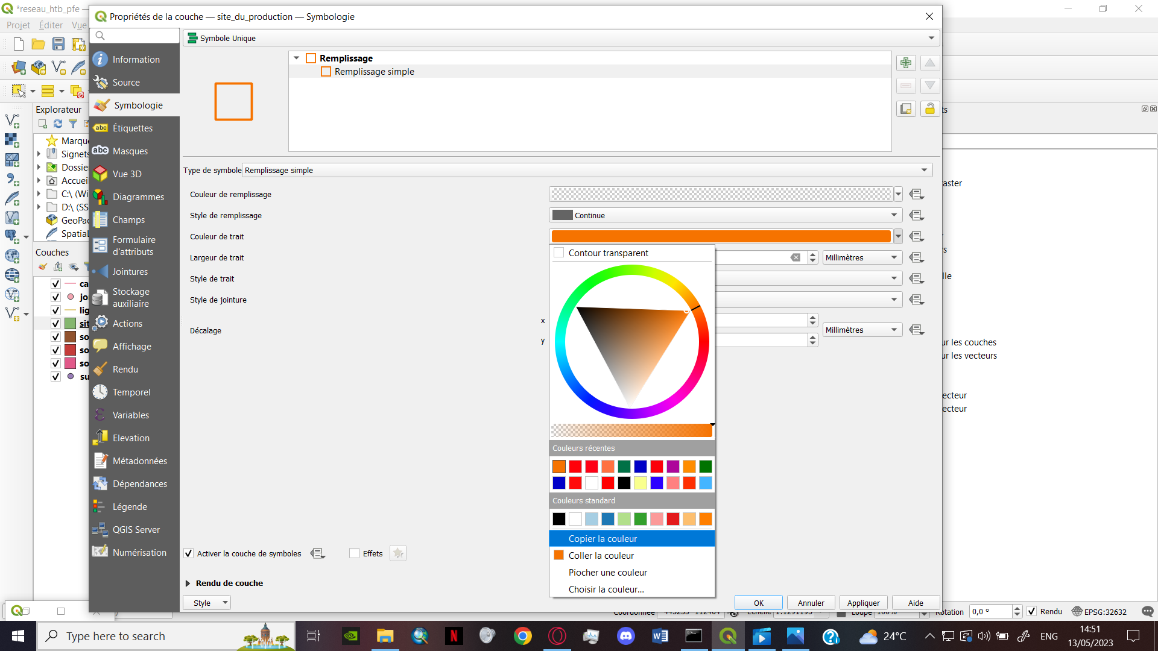

Figure : symbology window

For more complex symbols, I used the SVG logos to represent the tables

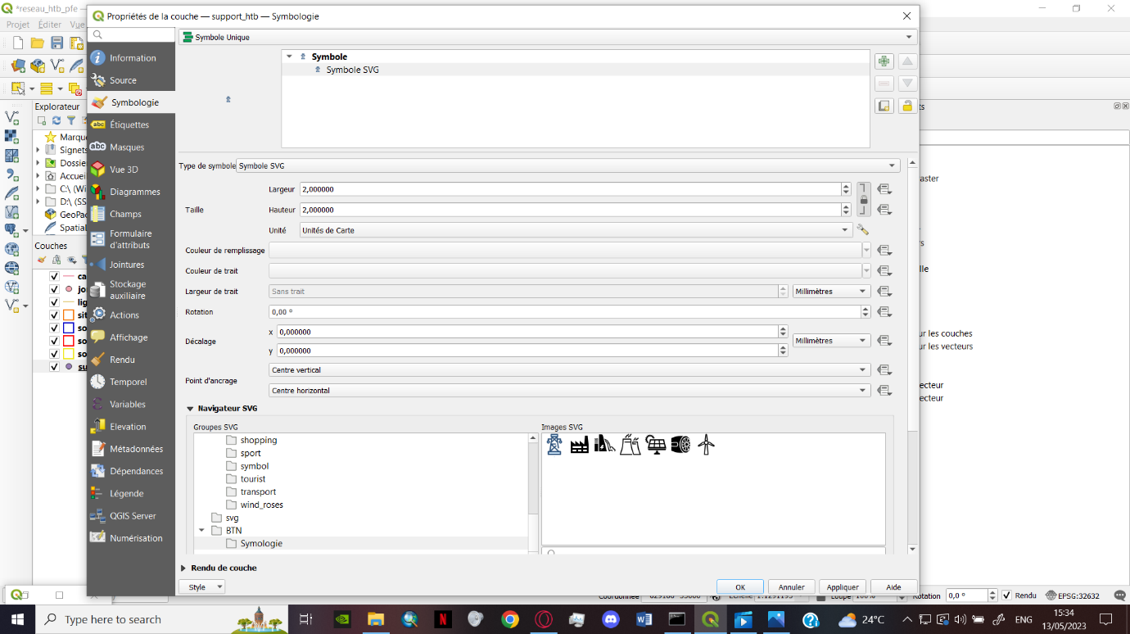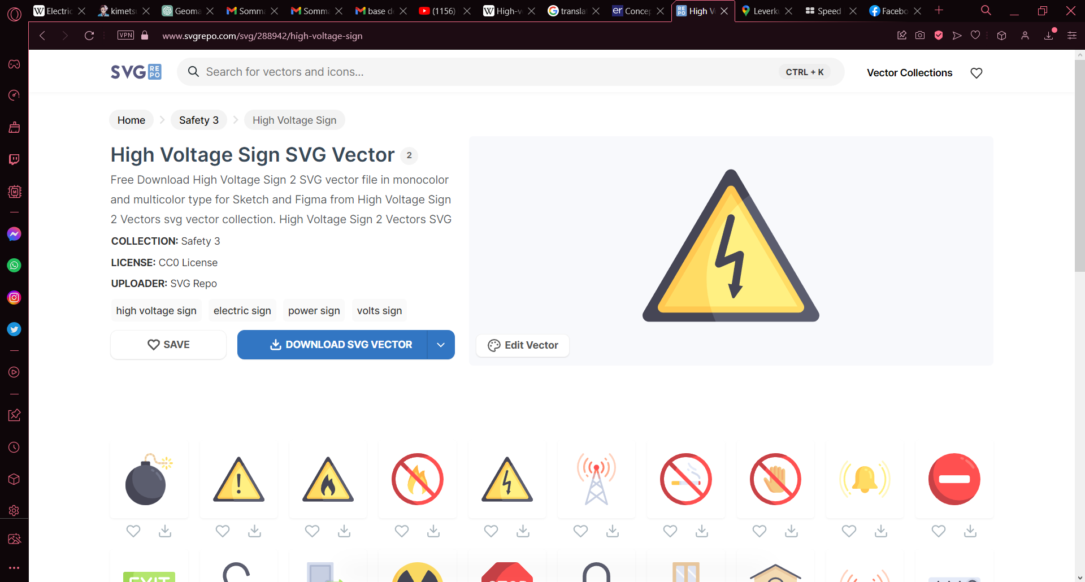1) I downloaded SVG logos from <https://www.svgrepo.com> .  
  
2) I choose (SVG Symbol), then choose the SVG from the directory

Figure : SVG options

Figure : SVG web site

Some layers has different symbols for different values of the features

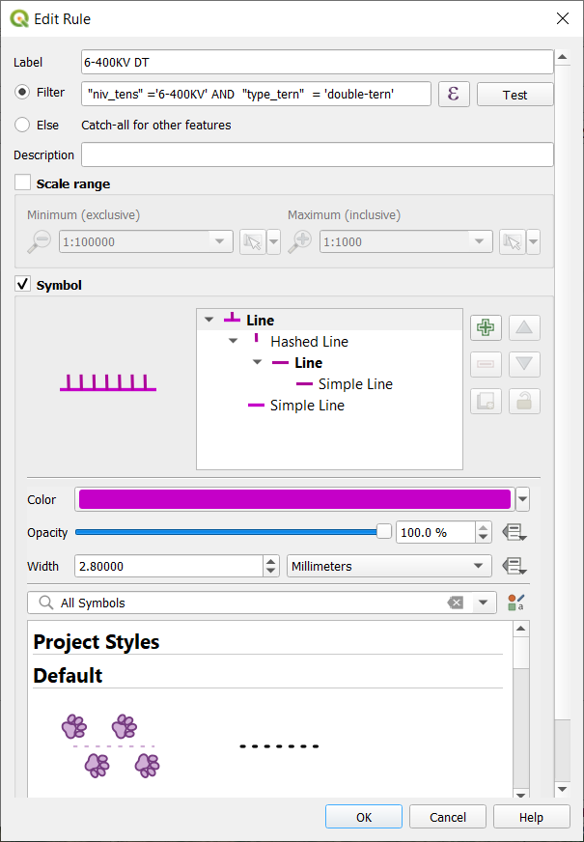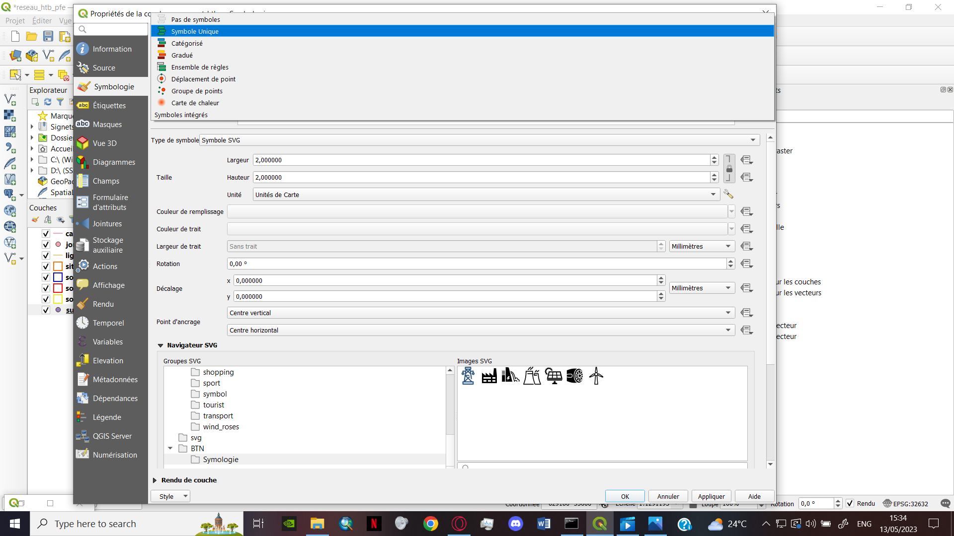1) I choose Rule-Based  
  
  
  
  
  
  
  
  
  
  
  
  
  
  
  
  
2) by click on the ‘ ℇ ’ the query builder windows pops to allow for the entering the script

Figure : Edit rule window

Figure : Rule based symbols

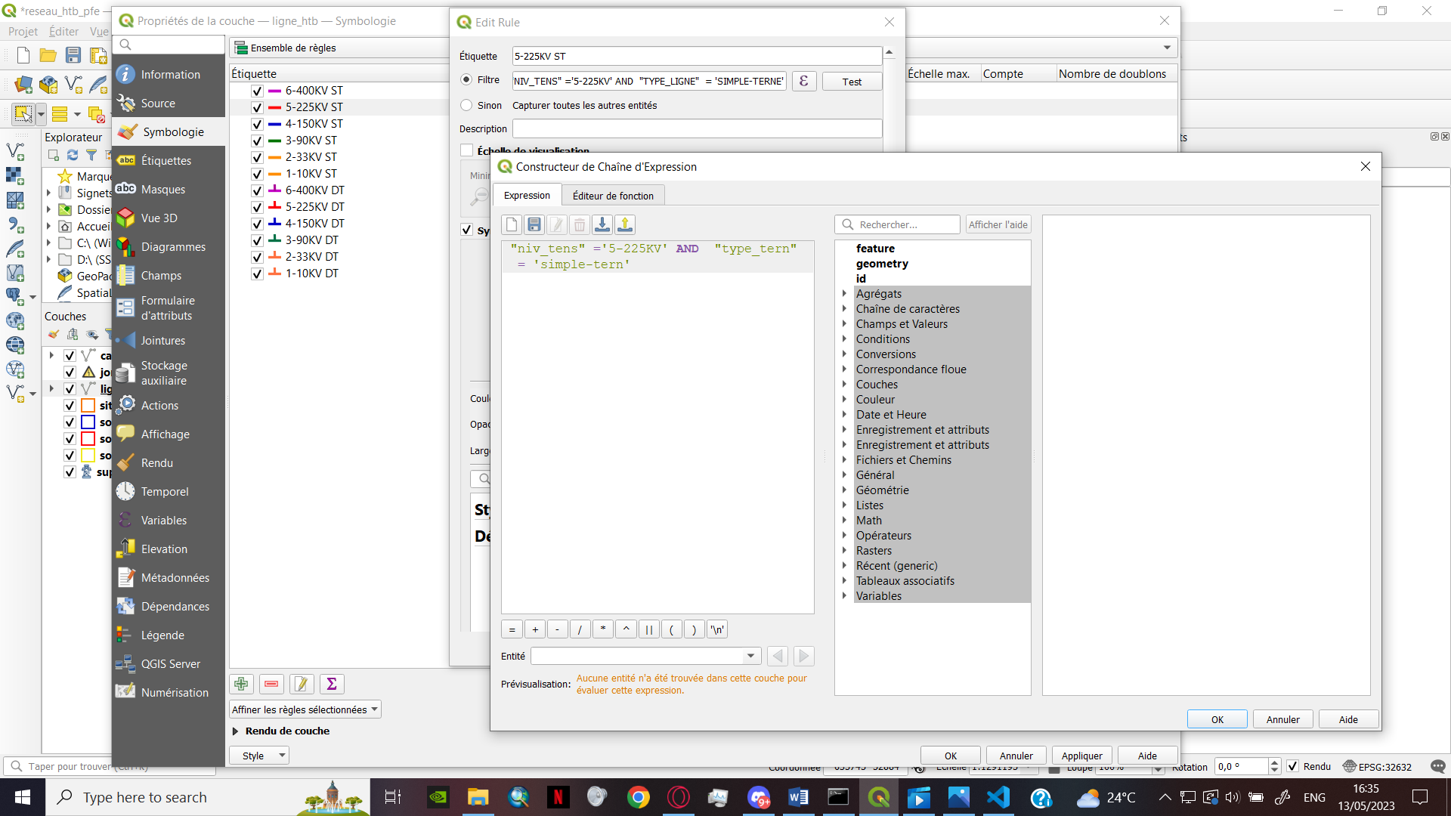

Figure : Query builder window

**The result:**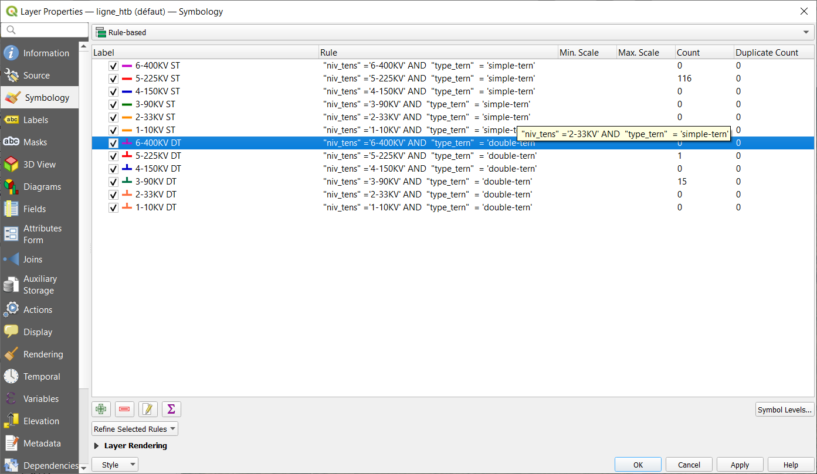

Figure : Different symbolgies for ligne_htb

## Digitization of the HTB network:

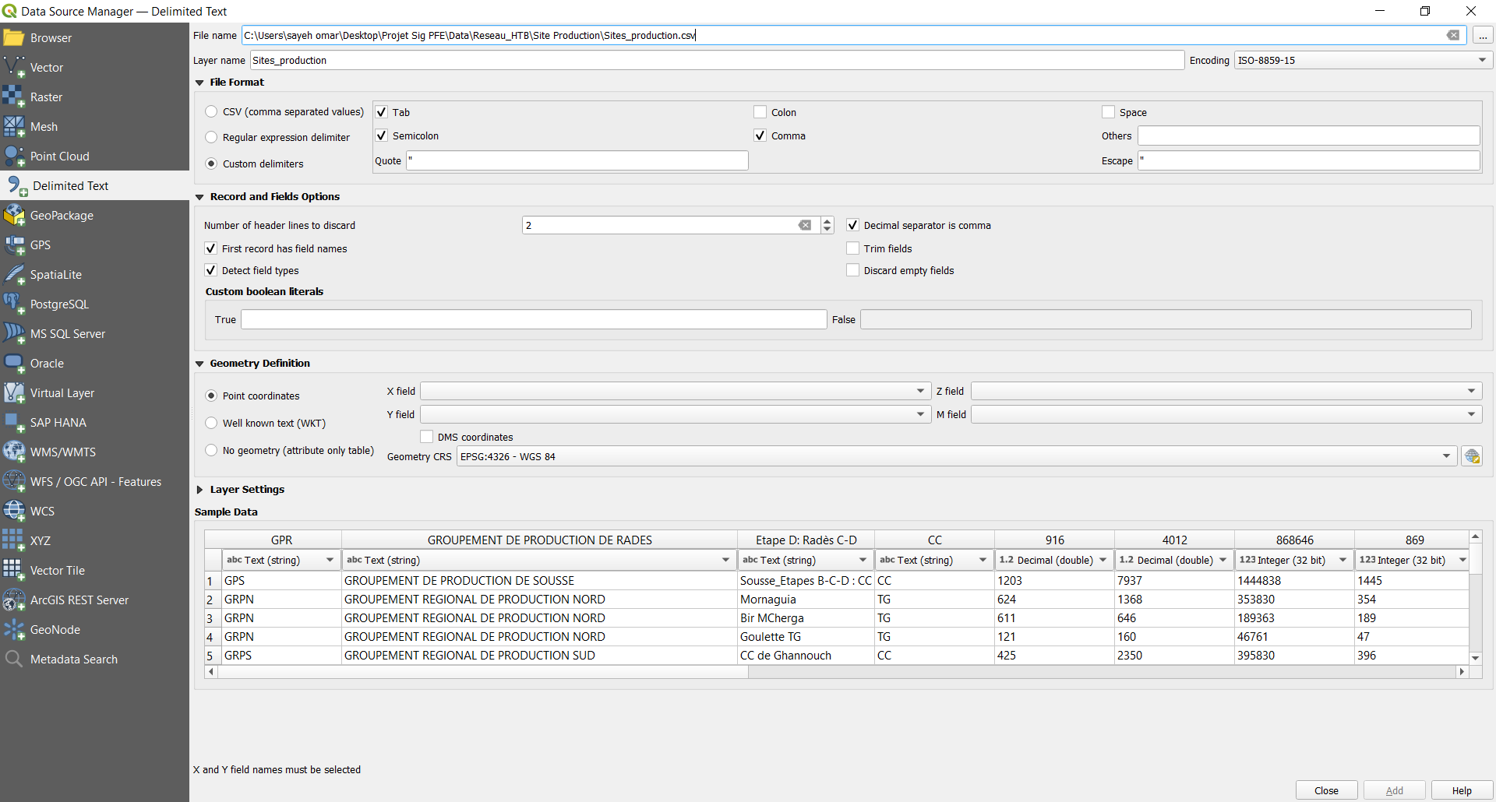1) Before starting to digitize, I had to import the data of the location of the layer (site_du_production) from the Delimited Text section from CSV file and apply symbology.

Figure : Inserting data from a CSV file

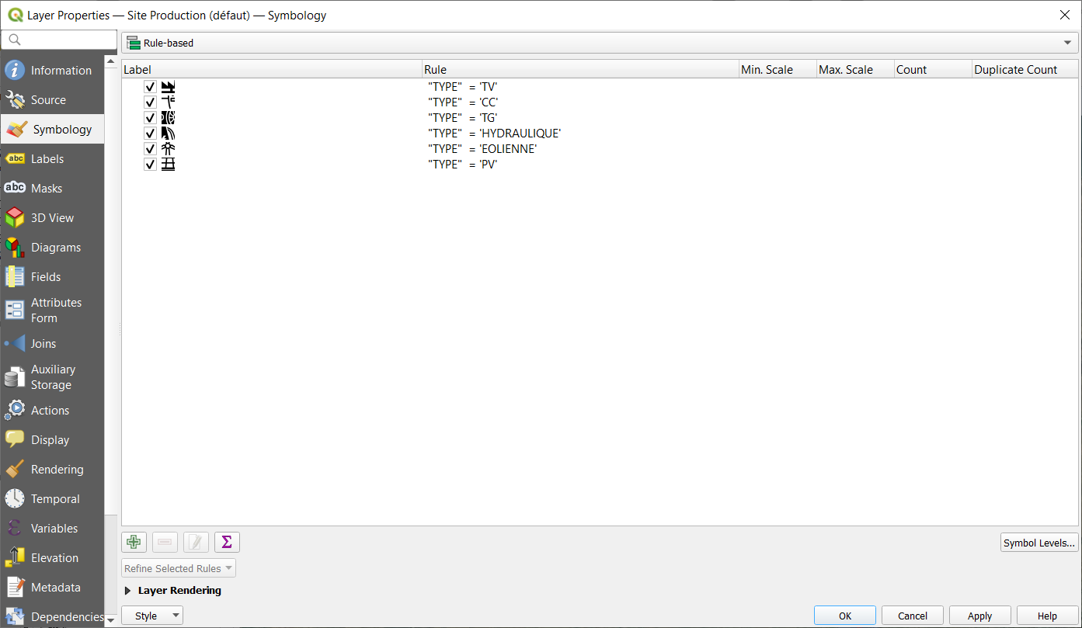

Figure : the Symbology applied

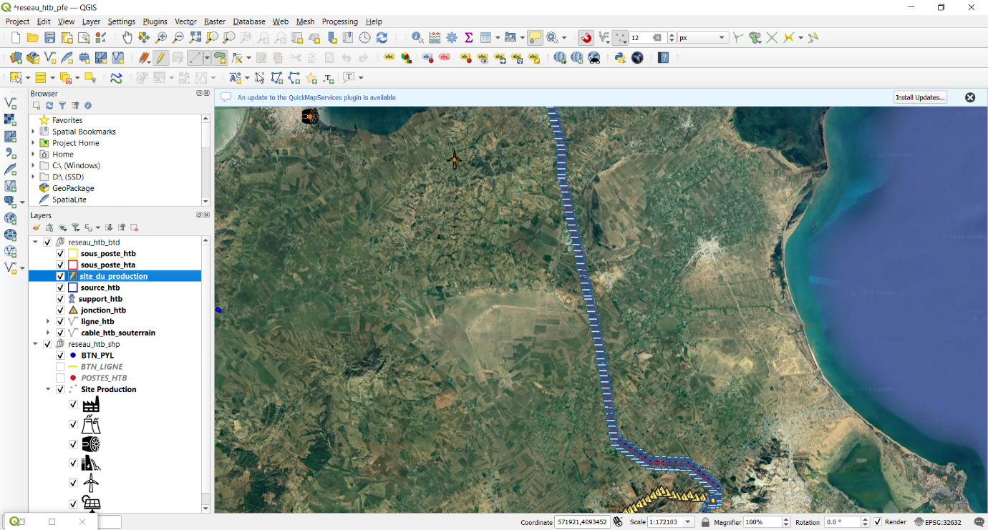2) To start digitizing, I choose a polygon layer, toggled editing then choose add polygon feature

Figure : Choosing the layer

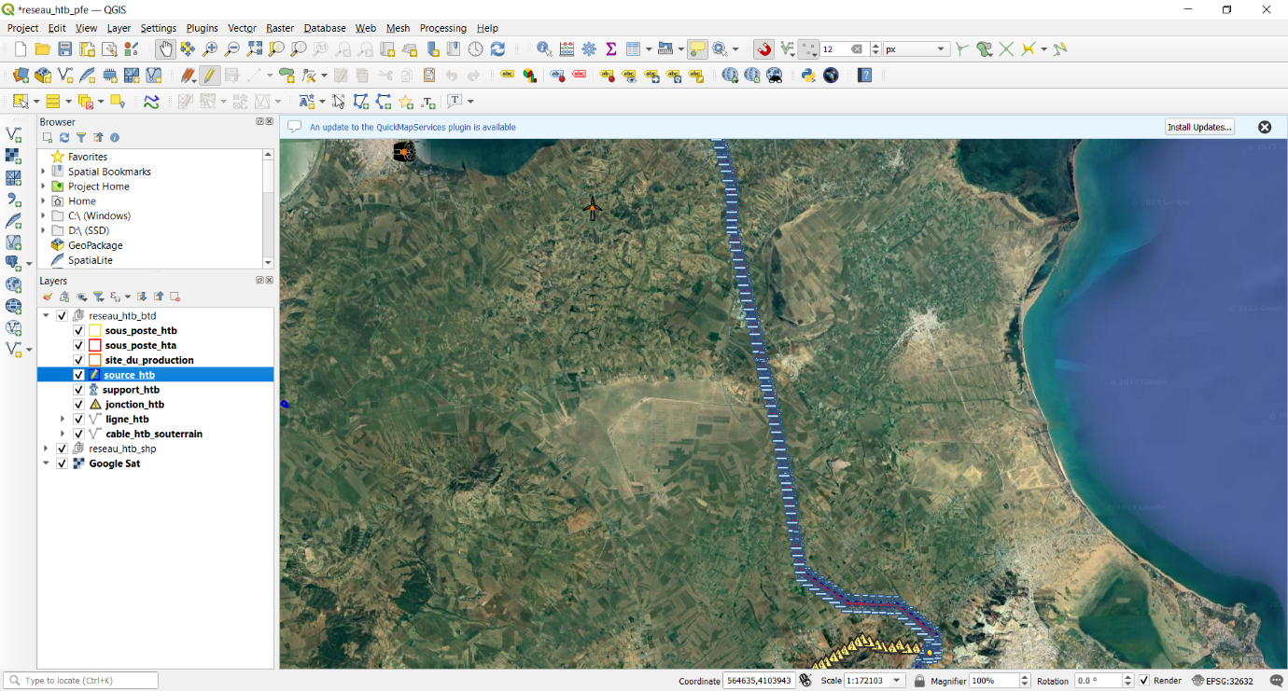  
  
  
3) To start digitizing click on the out posts of the location to shape the form of the layer

Figure : Toggling the edit option

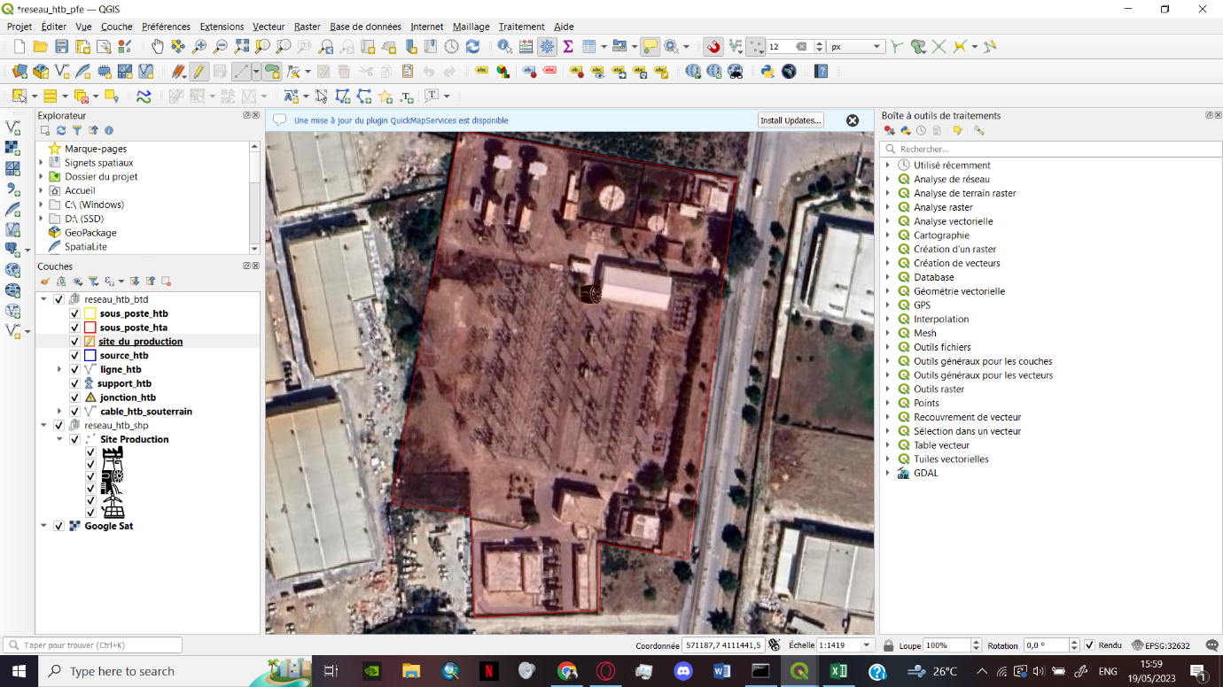

Figure : Drawing the shape of the production site

4) After finishing the shape a left click opens the widow to fill the features of the table

The (**✓**) means that the features has to be unique.

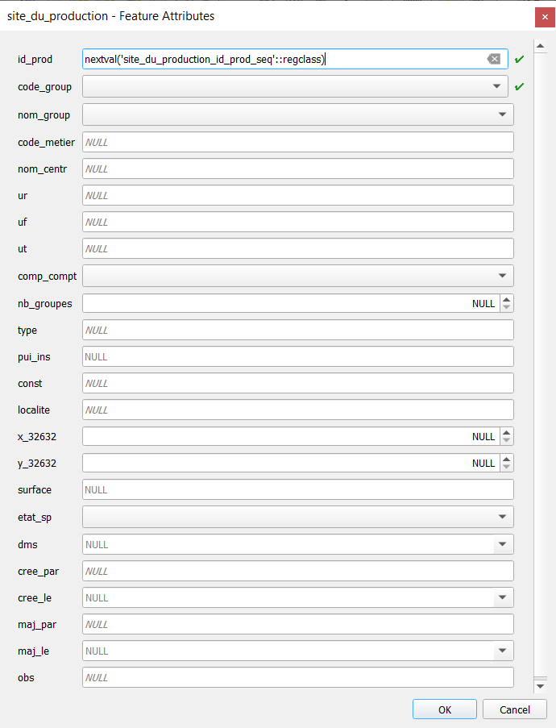

Figure : Attribution window

1) To show the information of a feature on the map canvas, I added labels controlling the value shown from the ‘ℇ’ option.

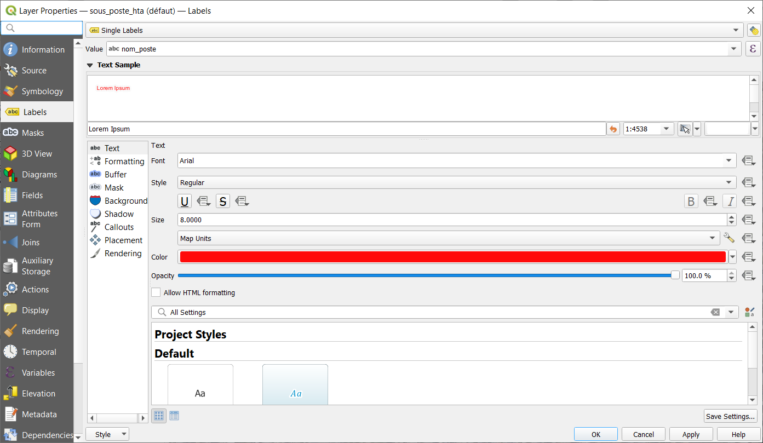

Figure : Labels window

2) I also added a buffer to make the labels visible on the map canvas

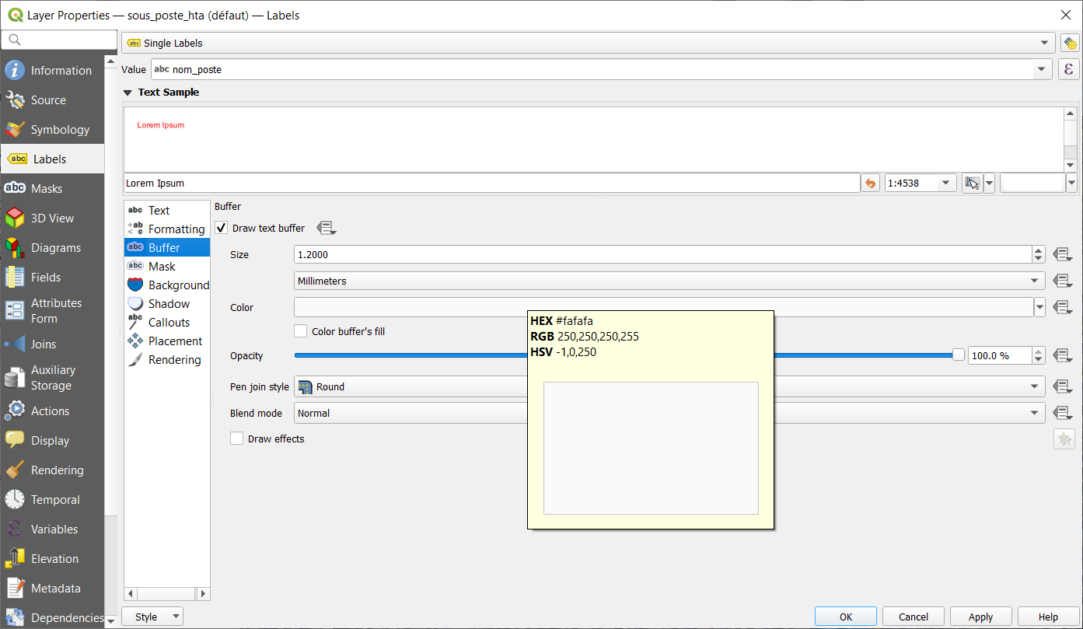

Figure : Buffer option

**The result:**

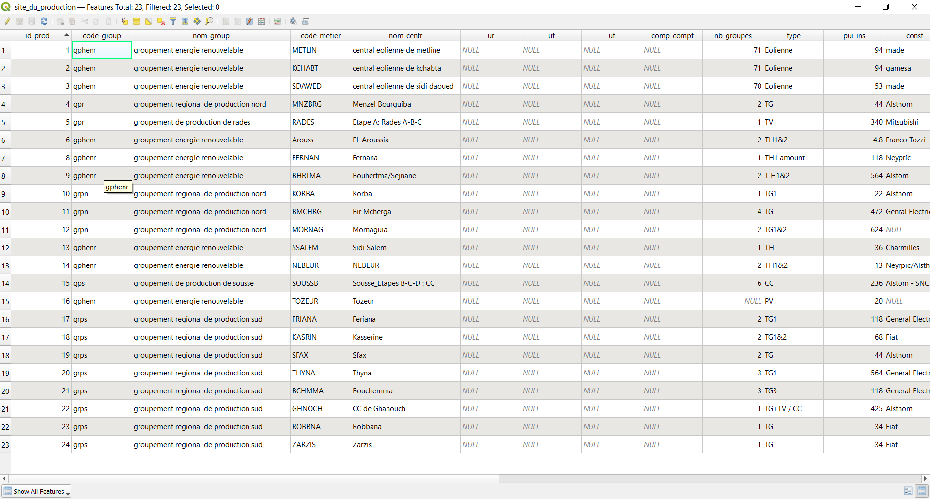

Figure : Attribute table

Code_group cardinality was changed later *

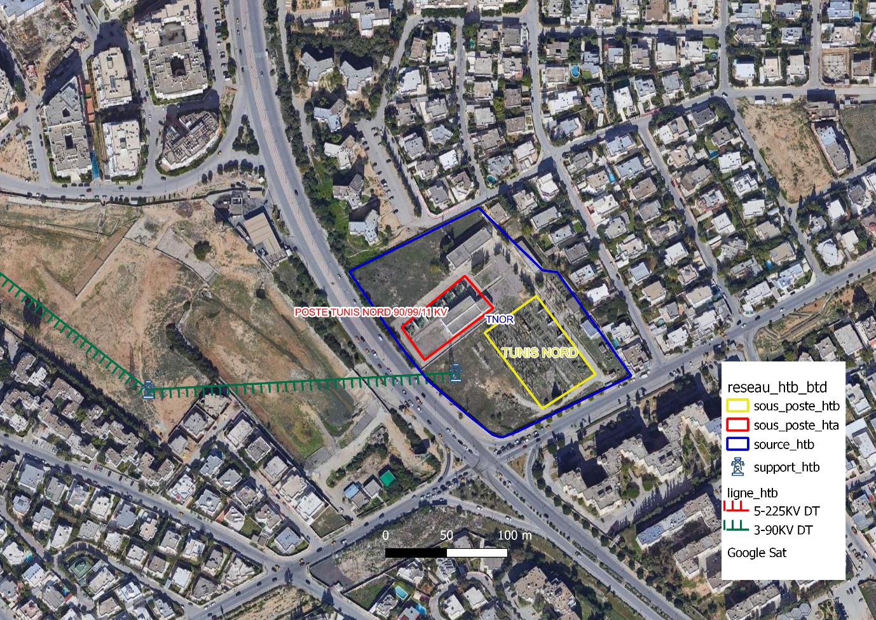

Figure : Map of the electricity source site Tunis Nord

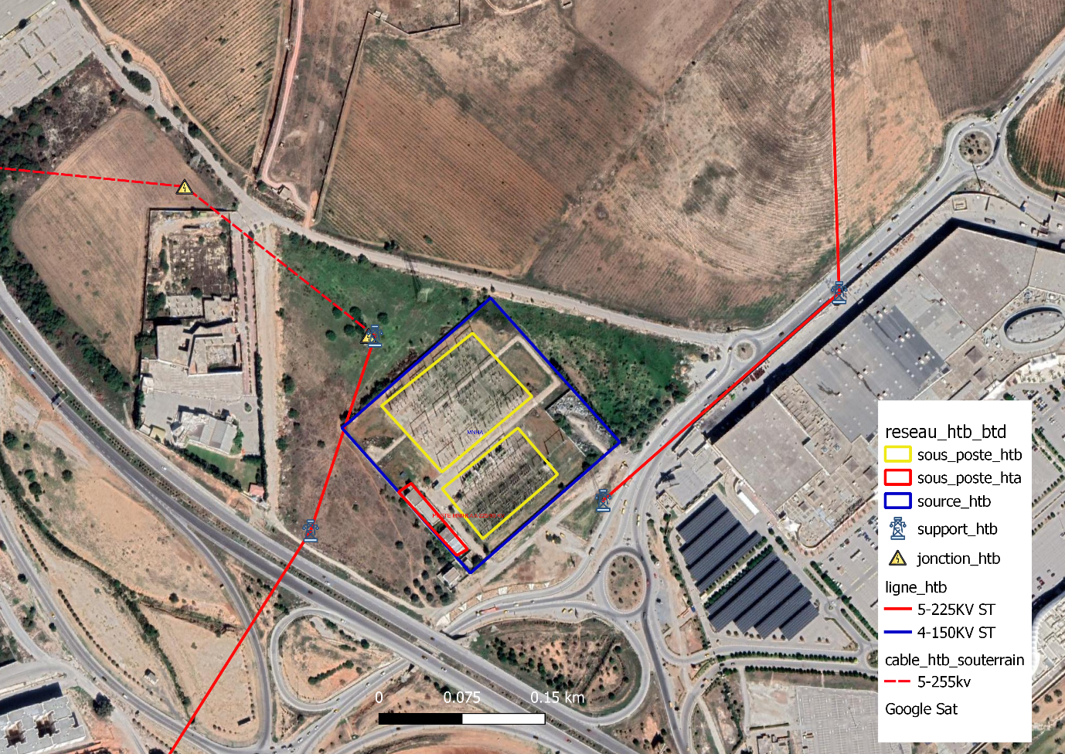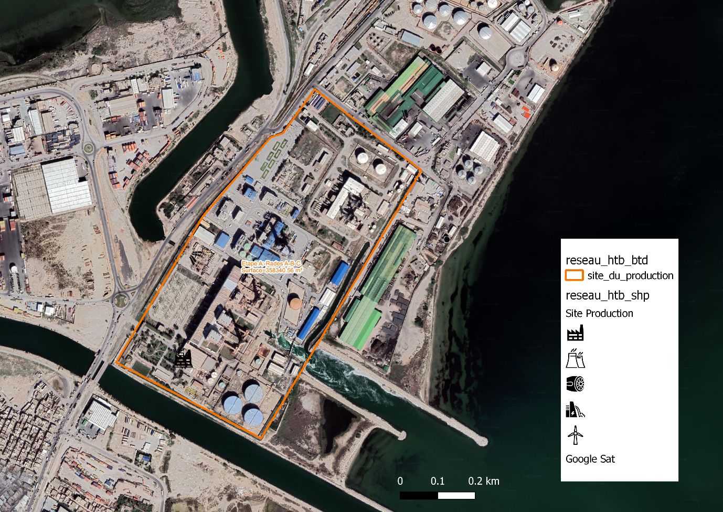

Figure : Map of the electricity source site Mnihla

Figure : Map of the electricity site Rades A-B-C

## SQL queries:

### Altering constraints, updating tables:

1) To remove the unique constraint from un_jnc:

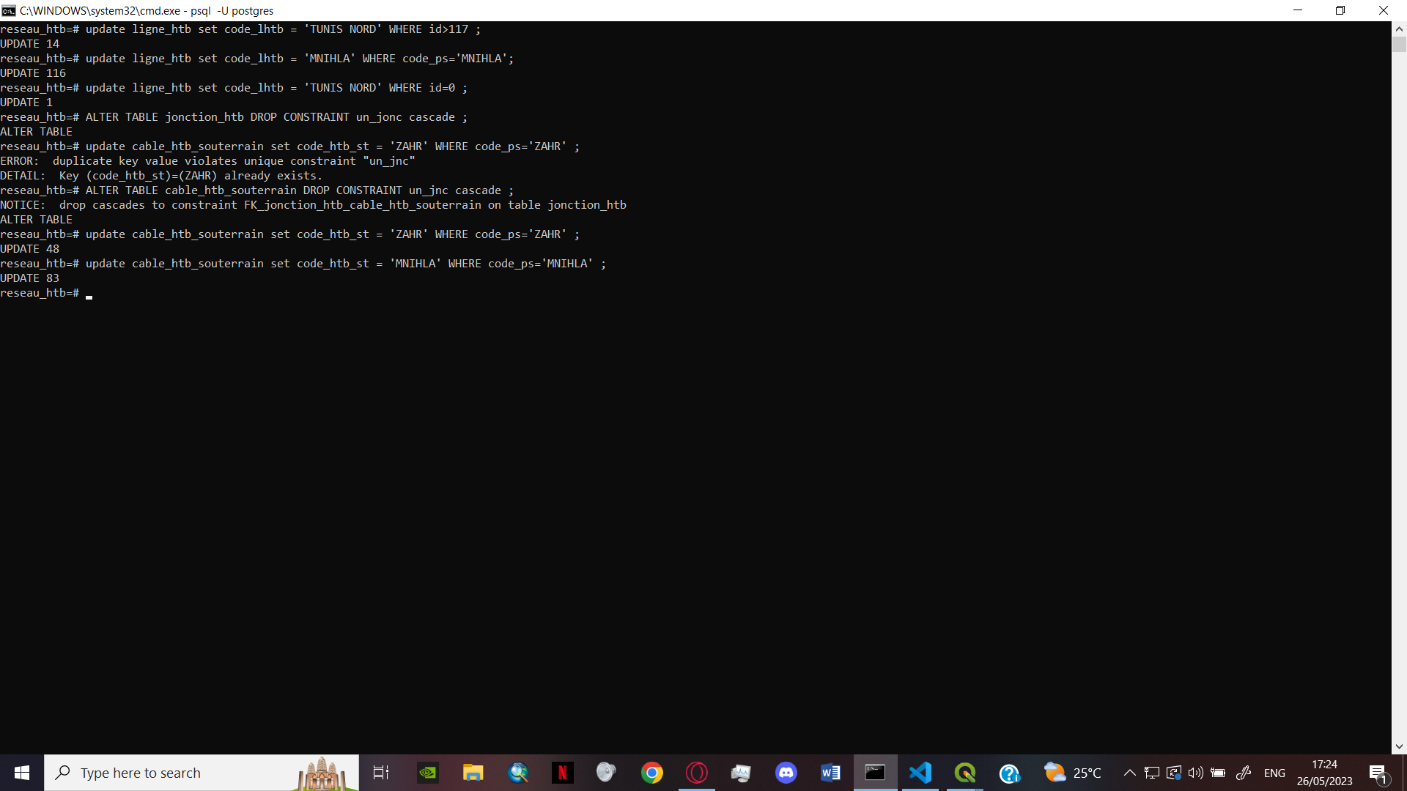**ALTER TABLE** cable_htb_souterrain **DROP CONSTRAINT** un_jnc **CASCADE ;**

Figure : Altering table constraint

2) To update the code_metier to match to start from zero every time its main value changes.

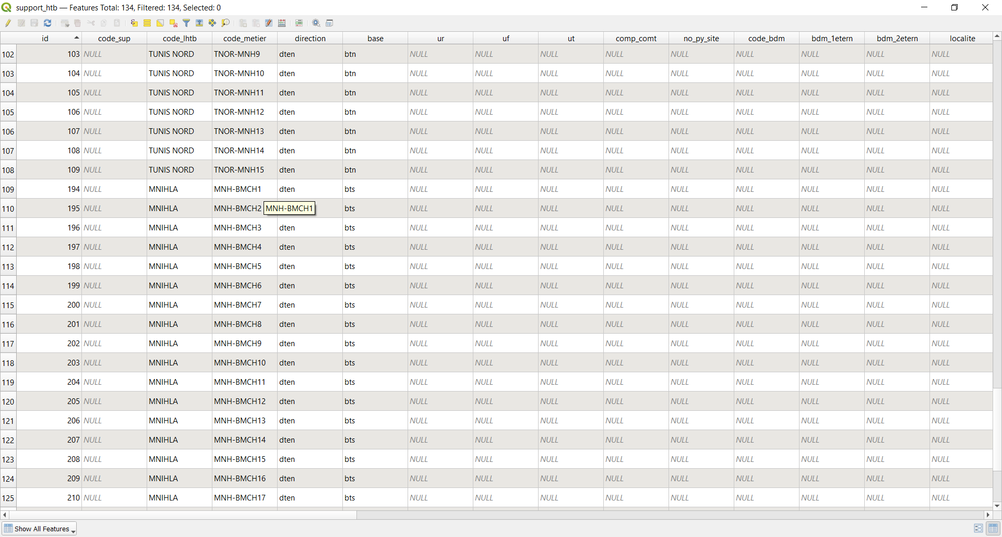Example:

Figure : Example of the update on the code_metier column

**UPDATE** support_htb

**SET** code_metier = 'MNH-BMCH' || **CAST**(id AS text)

**WHERE** id>108;

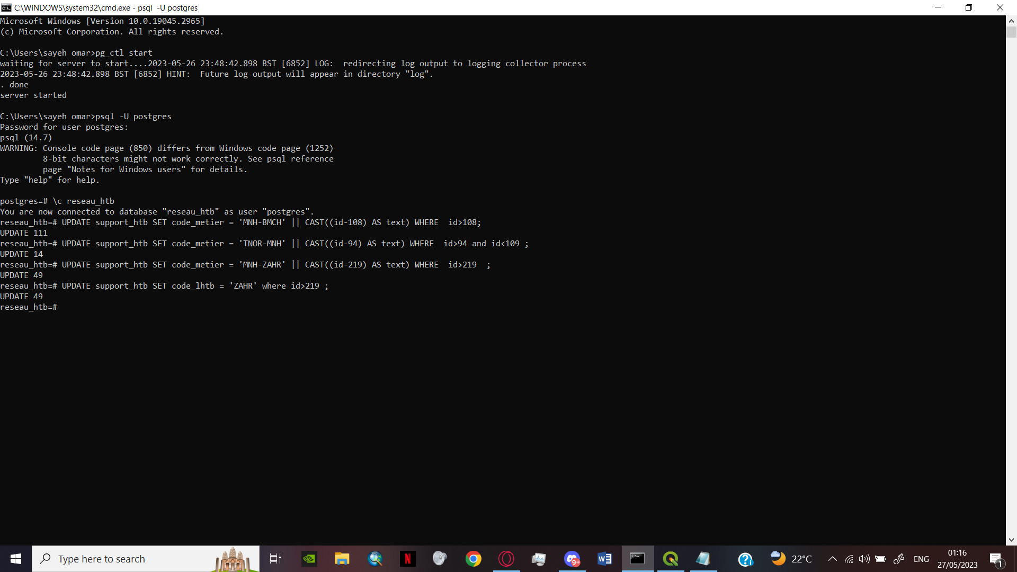

Figure : Updating the code_metier column with a query

3) Update code_lhtb of the ligne_htb table to ‘TUNIS NORD’ where the id > 117.

**UPDATE** ligne_htb

**SET** code_lhtb

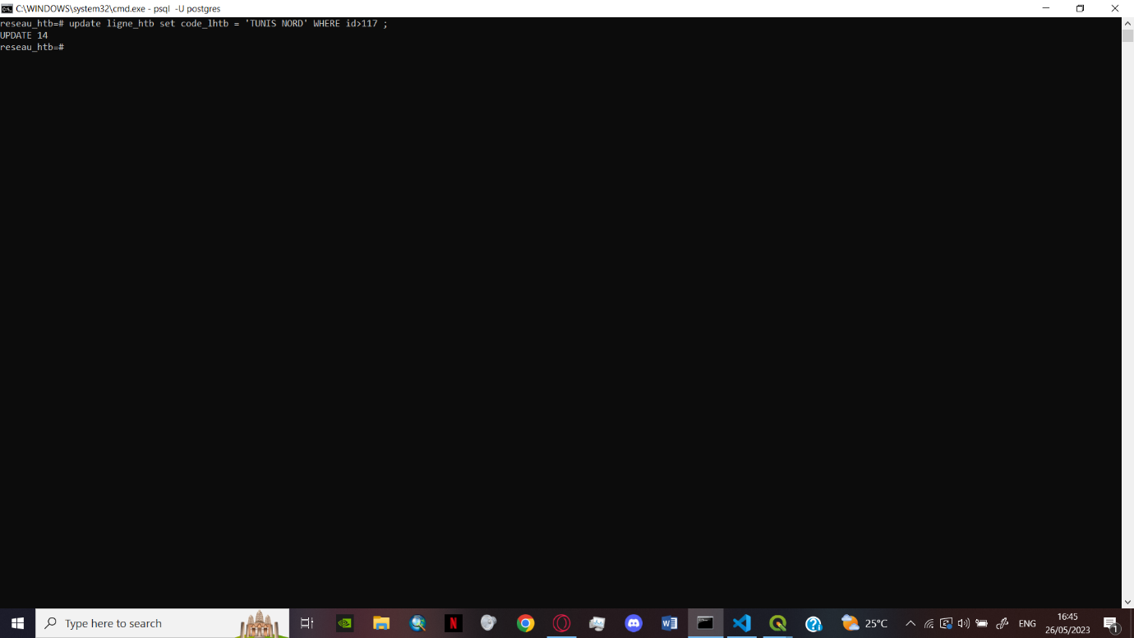**WHERE** id>117;

Figure : Updating the code_lhtb value with a condition

### Verification of digitized data in PostgreSQL/PostGIS:

To verify the data base, I used the following query structure + condition:

**SELECT** column_name **FROM** table_name;

1) To check the id_htb,code_metier,gouv,salle_cmde of the table source_htb in an ascending order :

**SELECT** id_htb,code_metier,gouv,salle_cmde

**FROM** source_htb

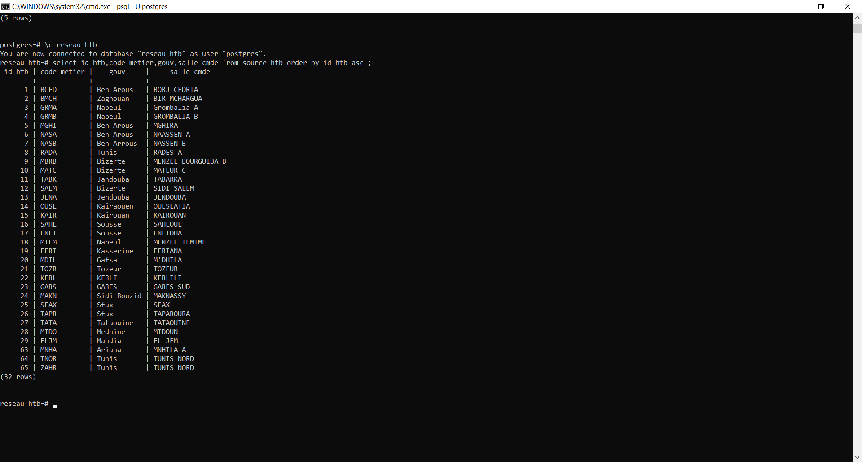**ORDER BY** id_htb asc ;

Figure : Representation of the value from the source_htb column

2) To check the id_prod,code_group,nom_centr,type of the table site_du_production that has TG1 as a type

**SELECT** id_prod,code_group,nom_centr,type

**FROM** site_du_production

**WHERE** type=’TG1’;

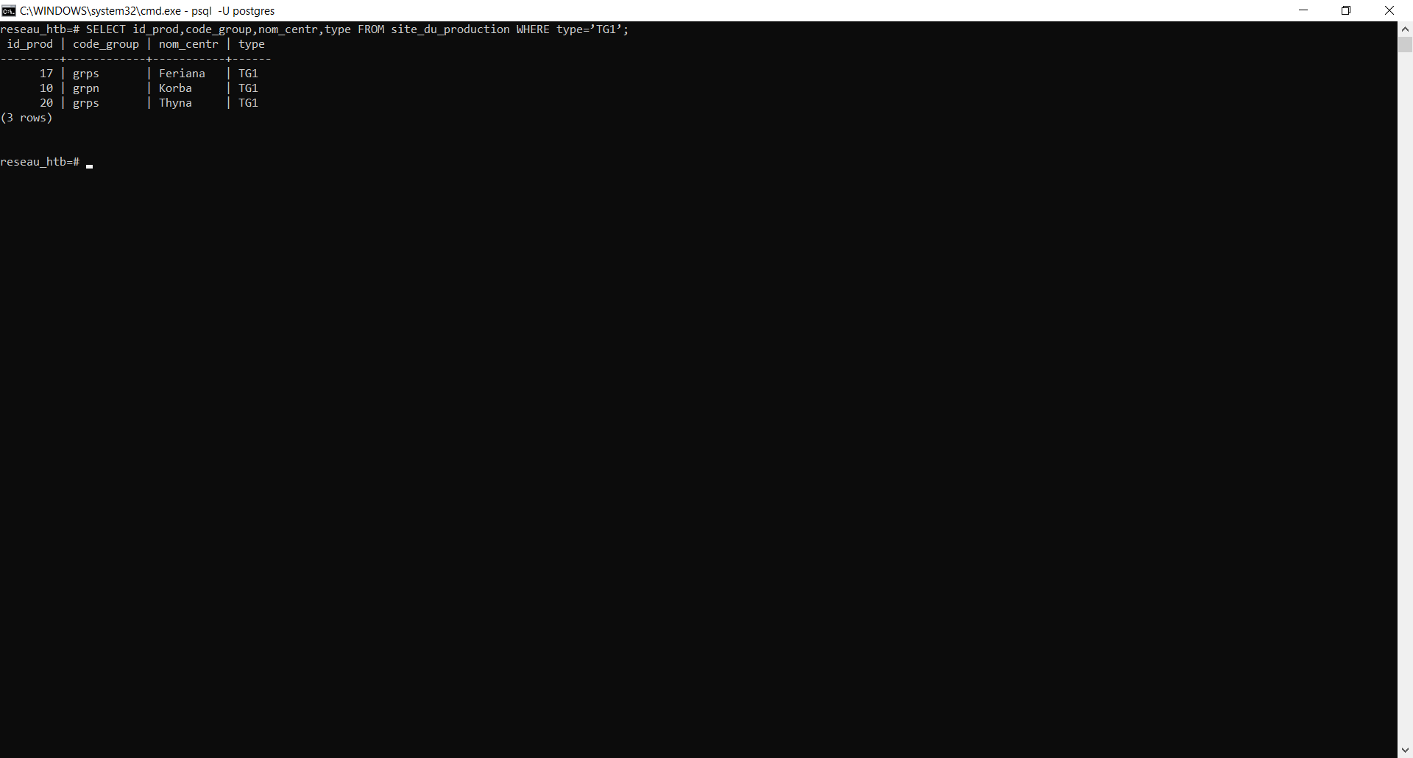

Figure : Representation of the values in the site_du_production with a condition on the type

3) To check for the working stat of the sous_poste_htb while showing the code_shtb and the Foreign Key.  
  
  
**SELECT** sous_poste_htb.code_shtb,sous_poste_htb.code_metier, sous_poste_htb.etat, source_htb.salle_cmde

**FROM** sous_poste_htb

**JOIN** source_htb

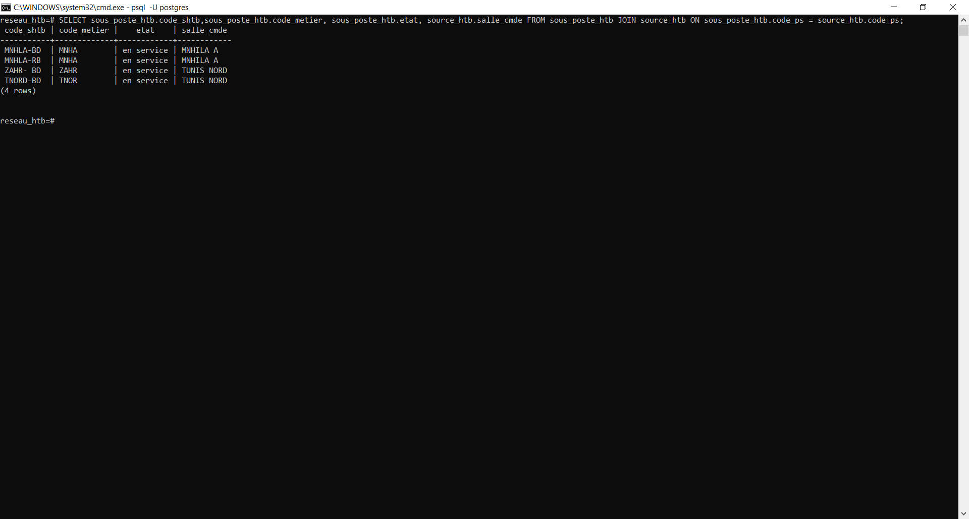**ON** sous_poste_htb.code_ps = source_htb.code_ps;

Figure : Representation of the values of the sous_pose_htb joined by source_htb with a condition on the FK code_ps

# Conclusion:

In conclusion, the integration of collected data to a Geographic Information System (GIS) via a PostgreSQL database offers numerous advantages and opens up new possibilities for efficient data management, analysis, and visualization.  
Through the use of PostGIS, the GIS ecosystem becomes more robust and capable of handling complex spatial operations and with ability to perform spatial queries and analysis directly within the database data processing becomes faster and more efficient, reducing the need for data transfer between multiple systems.  
Overall, the integration of geospatial data to a GIS via a PostgreSQL database empowers The ‘STEG’ with the tools and capabilities needed to effectively manage, analyse, and visualize spatial data.

# Tables:

Table 1: HV-MV Electricity Sales by Economic Sector 5

Table 2: Voltage Description 8

# Figure :

Figure 1: Electricity balance 4

Figure 2: Electricity activities 6

Figure 3: Breakdown of installed power STEG and CPC by type of power plant 6

Figure 4:500 kV three-phase electric power Transmission Lines 7

Figure 5: A diagram of an electric power system. 8

Figure 6:Electricity generation , transmission and distribution 9

Figure 7: Contributors and Users of the GEOMATICS 10

Figure 8: Raster representation 11

Figure 9: Vector representation 11

Figure 10: GIS data layering 12

Figure 11: The different components of a geographic information system. 13

Figure 12: PostgreSQL logo 15

Figure 13:PostGIS logo 16

Figure 14: ENTERPRISE ARCHITECT’s logo 16

Figure 15: Adding a model 17

Figure 16:Basic PostgreSQL Model 18

Figure 17: Default Tables 19

Figure 18: Creating the Tables 19

Figure 19: Adding the Features 20

Figure 20: Selecting the DBMS PostgreSQL 20

Figure 21: Example of table with its features 21

Figure 22: Adding the constraints 22

Figure 23:PK of the site_du_production 23

Figure 24:PK and FK of the source_htb 23

Figure 25: The association arrow 23

Figure 26: An association being drawn between two tables 24

Figure 27: Association option 24

Figure 28:Foreign key Constraint 25

Figure 29: Foreign key Constraint 25

Figure 30:Type of Cardinalities 26

Figure 31: An association has been created 27

Figure 32: The different association between the tables 27

Figure 33: Task bar - DDL 28

Figure 34: Task bar -Code 28

Figure 35: Exporting the database schema 28

Figure 36: Generate DDL window 29

Figure 37: Visual Studio Code’ logo 30

Figure 38: A drop-list for the regional groups 31

Figure 39: A drop-list for the code group 32

Figure 40: A drop-list for the different degrees of voltages 32

Figure 41:Settings window 33

Figure 42: Environment variables 33

Figure 43: Edit environment variable 34

Figure 44: Edit system variable 34

Figure 45: Starting the PostgreSQL server 35

Figure 46: Entering the user name and the password 35

Figure 47: Creating/Inspecting/Deleting a database 36

Figure 48: The SQL code being injected 37

Figure 49: Injecting the SQL into the database reseau_htb 37

Figure 50: QGIS LOGO 38

Figure 51: New Connection PostGIS window 39

Figure 52: The tables brought to QGIS 40

Figure 53: The Tables as geospatial layers 40

Figure 54: The symbology window 41

Figure 55: unique symbol 42

Figure 56: symbology window 42

Figure 57: SVG options 43

Figure 58: SVG web site 43

Figure 59: Edit rule window 44

Figure 60: Rule based symbols 44

Figure 61: Query builder window 45

Figure 62: Different symbolgies for ligne_htb 45

Figure 63: Inserting data from a CSV file 46

Figure 64: the Symbology applied 46

Figure 65: Choosing the layer 47

Figure 66: Toggling the edit option 47

Figure 67: Drawing the shape of the production site 48

Figure 68: Attribution window 49

Figure 69: Labels window 50

Figure 70: Buffer option 50

Figure 71: Attribute table 51

Figure 72: Map of the electricity source site Tunis Nord 51

Figure 73: Map of the electricity source site Mnihla 52

Figure 74: Map of the electricity site Rades A-B-C 52

Figure 75: Altering table constraint 53

Figure 76: Example of the update on the code_metier column 53

Figure 77: Updating the code_metier column with a query 54

Figure 78: Updating the code_lhtb value with a condition 54

Figure 79: Representation of the value from the source_htb column 55

Figure 80 : Representation of the values in the site_du_production with a condition on the type 56

Figure 81: Representation of the values of the sous_pose_htb joined by source_htb with a condition on the FK code_ps 56

# Bibliography

1. **OpenAI. (n.d.) . *GPT-3.5 Language Model.* [Online] 05 2023. https://chat.openai.com/.**

**2. *A Primer on Electric Utilities, Deregulation, and Restructuring of U.S. Electricity Markets.* s.l. : United States Department of Energy Federal Energy Management Program, 2002.**

**3. wikipedia. *wikipedia.org.* [Online] 05 2023. https://en.wikipedia.org/wiki/Electric_power_transmission#cite_note-femp01-1.**

**4. GISGeography ,What is GIS? A Guide to Geographic Information Systems. *GISGeography.* [Online] 23 04 2023. https://gisgeography.com/what-is-gis/.**

**5. Erwin by Quest. *Erwin by Quest.* [Online] https://www.erwin.com/solutions/data-modeling/conceptual.aspx#:~:text=The%20aim%20of%20a%20conceptual,-role%20models%20(ORM)..**

**6. IBM. *IBM.* [Online] https://www.ibm.com/docs/en/data-studio/4.1.1?topic=SS62YD_4.1.1/com.ibm.datatools.logical.ui.doc/topics/clogmod.html.**

**7. Wikipedia PostgreSQL. *Wikipedia.* [Online] https://en.wikipedia.org/wiki/PostgreSQL.**

**8. Postgis. *Postgis.* [Online] https://postgis.net.**

**9. Wikipedia , Enterperise Architect. *Wikipedia.* [Online] https://en.wikipedia.org/wiki/Enterprise_Architect_(software).**

**10. Wikipedia SQL. *Wikipedia.* [Online] https://en.wikipedia.org/wiki/SQL.**

**11. Wikipedia QGIS. *Wikipedia.* [Online] https://en.wikipedia.org/wiki/QGIS.**

**12. *Memoire Mastère.* Ghada, Selmi Hiba & Askr. 2019, L'apport de l'utilisation SIG dans l'automatisation desnouveaux projets de distribution des réseaux de la STEGet la cartographie statistique.**